**Session A.**

**Review of 2011 APEC Basic GReVP Workshop**

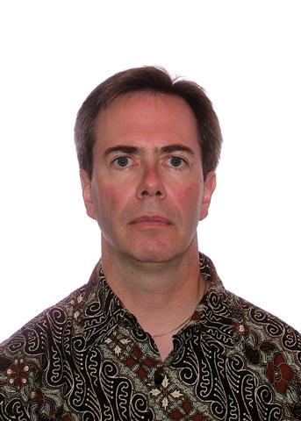

**Mike Ward**

Mike Ward joined Health Canada in 1986 following nine years industrial experience in the QA/QC area. Since that time he has held a variety of regulatory positions including GMP specialist, premarket Quality reviewer and manager, and senior policy analyst. Mike is Manager of the International Programs Division of the Therapeutic Products Directorate of Health Canada. He served as the Canadian Observer to the ICH Steering Committee and a former regulatory co-chair of the Global Cooperation Group. He chairs the Regulatory Harmonization Steering Committee of the APEC Life Sciences Innovation Forum and is an alternate representative for NAFTA on the PanAmerican Regulatory Harmonization Steering Committee.



**Li-Ling Liu**

**Current position: Director, Division of Medical Devices and Cosmetics, Taiwan FDA**

**E-mail :** [**LLL@fda.gov.tw**](mailto:LLL@fda.gov.tw)

**Education:**

1985.9~1987.8 M.S. of Pharmaceutical Science, Wayne State University, USA

1976.9~1980.6 B.S. of Pharmacy in National Taiwan University

**Working experience:**

2010.1~present Director, Division of Medical Devices and Cosmetics, Taiwan FDA

1988.9~2009.12 Bureau of Pharmaceutical Affairs, Department of Health

(2005.1~2009.12 Deputy Director General)

1987.9~1988.8 Kaiser Medical Center, USA

1984.11~1985.8 Pharmacist in National Taiwan University Hospital

1980.7~1984.10 Pharmacist in Mackay Memorial Hospital

**License:**

Pharmacist License, ROC

Pharmacist License, USA

**Membership:**

Member of Regulatory Harmonization Steering Committee (RHSC), APEC LSIF

Board Director of Taiwan Blood Services Foundation

**Session B.**

**Quality System for Reviewers**



**Deborah Jansen**

Work History

* Center Quality Manager, since June 2008
* Center Laboratory Quality Manager, September 2002 to June 2008
* Quality Assurance Coordinator of the Division of Bacterial Parasitic and Allergenic Products, July 2001 February 2002
* Product Application Reviewer, 1992 through 2002
* FDA Inspector, 1993 through 2002
* Develop and implement GLP and ISO 17025 practices in a quality control testing laboratory, October 1999 to July 2001
* Quality control testing of US licensed pertussis vaccine products, 1989 through 1994

Projects

* Conducted training program in quality control testing for representatives of the Russian and Egyptian health authorities in collaboration with USAID
* Designed and conducted an investigation into the potency and stability of a vaccine Standard.
* Prepared and characterized a vaccine Standard. Organized and conducted an international collaborative study to define the methods for its use
* Commissioned and collaborated on the production of statistics software for analysis of vaccine testing data
* Research Development of diagnostic methods for pertussis infection involving novel application of existing technology

Professional Certifications

* Villanova University Certified Lean Six Sigma Black Belt
* ASQ Certified Manager of Quality/Organizational Excellence
* ASQ Certified Quality Auditor
* ASQ Certified Quality Improvement Associate

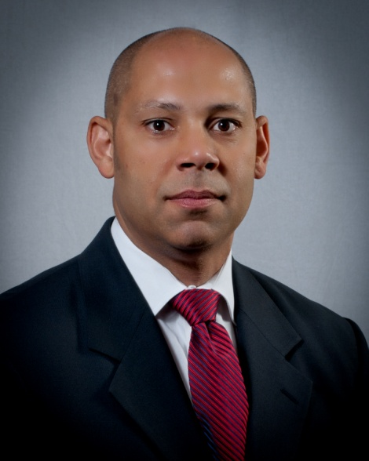

**David Cummings**

I am currently employed as the Associate Director for Quality for the Office of Pharmaceutical Science in the Center for Drug Evaluation and Research at the US Food and Drug Administration. I am trained as an analytical chemist. I am an American Society for Quality (ASQ) Certified Quality Auditor and Manager of Quality/Organizational Excellence. I worked in the pharmaceutical industry for 11 years (brand name and generic) before joining FDA. Over the past 14 years at the US FDA, I have worked in the new drug and generic drug programs as a review chemist, counter-terrorism as a project officer, guidance development, and policy development programs. I also served as the Executive Secretary for the Office of Pharmaceutical Science Coordinating Committee that establishes and implements policy for OPS programs. Now, I lead OPS's effort to implement an ISO 9001 quality management system and chair the OPS Chemistry, Manufacturing, and Controls Quality System Board. I am also a member of the US Technical Advisory Group to ISO Technical Committee 176 on Quality Management System.



**Caroline Vanneste**

Caroline Vanneste joined Health Canada in 1992 as a pharmaceutical quality evaluator. She was the Canadian pharmaceutical quality representative on the ICH Expert Working Group for the Common Technical Document from 1998 to 2000, a Visiting Expert at the European Medicines Agency in London, England from January to April 2003, and a member of the U.S. Pharmacopeia Aerosols Expert Committee from 2000-2010. She was also a co-author of the 2006 joint Health Canada – European Union Guidance on Pharmaceutical Quality of Inhalation and Nasal Products.

Caroline has been the Project Manager for Good Review Practices at the Therapeutic Products Directorate since the project was launched in 2004. In this capacity, Caroline plans and directs the development and delivery of standard operating procedures and training for pharmaceutical and medical device quality, safety, and efficacy reviewers. In 2010-2011, Caroline led the Health Products and Food Branch Foreign Reviews Working Group, which developed the draft framework, standard operating procedure, and industry guidance document, currently being piloted in the Biologics and Genetic Therapies Directorate, the Marketed Health Products Directorate, the Therapeutic Products Directorate, and the Veterinary Drugs Directorate.

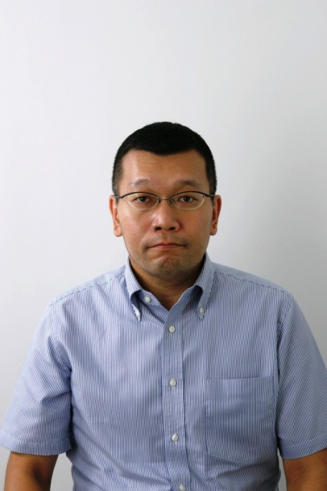

**Naoyuki Yasuda**

Mr. Naoyuki Yasuda, International Planning Director, Minister’s Secretariat, Ministry of Health, Labour and Welfare, Japan, was born and raised in Hokkaido. He graduated from the Faculty of Pharmaceutical Science, Osaka University in 1991.

He joined Ministry of Health and Welfare (former MHLW) in 1991 and began his career at Guidance and Inspection Division, Pharmaceutical Affairs Bureau. He was careered in Ministry of International Trade and Industry for Space industry issue in 1995, Administrator, Organization of Economics, Cooperation and Development (OECD) for the hazard assessment of existing chemicals in 1998, Deputy Director, Office of Medical Devices Evaluation, Pharmaceutical and Food Safety Bureau, MHLW in 2003, 1st Secretary, Permanent Mission of Japan to the International Organizations in Vienna for international cooperation on Narcotics and pychotropics in 2005, and Planning Director, Blood and Blood Products Division, Pharmaceutical and Food Safety Bureau, MHLW for blood safety and vaccines supply in 2010.

He has taken his position as International Planning Director, MHLW from August 2011.

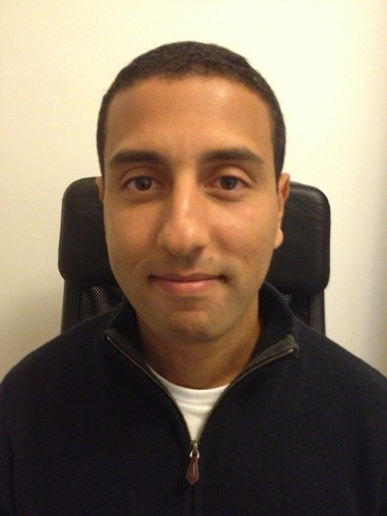

**Aimad Torqui**

He obtained a degree in biotechnology engineering (HAN University of Applied Sciences), in molecular biology and business administration at the University of Nijmegen. He works at the Medicines Evaluation Board (MEB) in the Netherlands for more than 6 years. Starting out as a regulatory project leader, he developed a broad experience in coordinating/assessing of national and European application procedures of medicinal products. His current position is as a staff member/Policy adviser of the department Policy, Governance and Regulatory Affairs. He is also acting as an alternate Member in the CMDh (the European Co-ordination Group of Mutual Recognition and Decentralized Procedures – Human) on behalf of the MEB.



**Larry Liberti**

For the past 34 years, Mr Liberti has worked in and with the pharmaceutical industry, in the fields of regulatory affairs and clinical R&D. He began his career at Wyeth Laboratories working in Product Development, as a regulatory writer in Clinical R&D, and Manager of Safety Surveillance in Medical Affairs. He served as the Editorial Director for the North American operations of ADIS international after which he founded PIA Ltd, a company specializing in regulatory writing and consulting; he co‐founded Astrolabe Analytica under which he helped develop, patent and commercialize the Astrolabe Message Mapping System TM . Both organizations became part of Thomson in 2005. Since 2009 he has served as the Executive Director of CIRS (the Centre for Innovation in Regulatory Science, Ltd; formerly the CMR International Institute for Regulatory Science), an independent division of the IP and Science business of Thomson Reuters.

Mr Liberti has been actively involved in promulgating best practices in the regulatory aspects of medicines development, especially in the emerging markets. He lectures on regulatory issues concerning expediting patient access to medicines, new paradigms of drug development and ways to improve communications between regulators, HTAs and sponsors. He serves on the Board of other not‐for‐profit organizations, including CONTACT Greater Philadelphia (a suicide prevention and elder outreach provider).

Mr. Liberti is a pharmacist with a master’s degree in pharmacognosy (both from the Philadelphia College of Pharmacy and Science). He is currently undertaking paralegal certification. He was awarded the status of Regulatory Affairs Certified (RAC) by the Regulatory Affairs Professional Society. He is a Fellow of the American Medical Writers Association and is a recipient of their Golden Apple award for excellence in teaching.



**Neil McAuslane**

|  |  |
| --- | --- |
| **ACADEMIC QUALIFICATIONS** | |
| (years) | (degrees) |
| 1986-1988 | PhD Clinical Pharmacology – Edinburgh University |
| 1984-1985 | MSc Toxicology – Surrey University |
| 1979-1984 | BSc (Hons) Pharmacology – Dundee |
| **PRESENT APPOINTMENTS** | |
| (years) | (positions) |
| 2011-present | Director, Centre for Innovation in Regulatory Science |
| **PREVIOUS APPOINTMENTS** | |
| (years) | (positions) |
| 2006 – 2010 | Director, CMR International Institute for Regulatory Science |
| 2004 –2006 | Chief Scientific Officer, CMR International |
| 1999 –2004 | Director Research Operations, CMR International |
| 1996 –1998 | Research Manager, CMR International |
| 1992-1995 | Project Manager, CMR International |
| 1988 –1991 | Postdoctoral Research Fellow, University of Wales, Department of Clinical Pharmacy University of Wales College Cardiff |
| **RESEARCH INTERESTS** | |
| Regulatory strategy and performance, R&D Performance | |
| Benefit Risk Assessment of new Medicines, Quality of decision making | |
| **CONTACT INFORMATION** | |
| (E-mail)nmcauslane@cirsci.org | |
| (TEL)+44 (0)207 433 4145 | |
| (Address) The Johnson Building, 77 Hatton Garden, London, England. EC1N 8JS, UK | |



**Yow Soh Zoem**

Soh Zeom obtained her PhD in Bioengineering and is currently a Regulatory Specialist with the Health Sciences Authority Singapore. She is an evaluator of general and in-vitro diagnostic medical devices.

**Session C.**

**Key Elements & Strategies of a Good Review**



**Caroline Vanneste**

Caroline Vanneste joined Health Canada in 1992 as a pharmaceutical quality evaluator. She was the Canadian pharmaceutical quality representative on the ICH Expert Working Group for the Common Technical Document from 1998 to 2000, a Visiting Expert at the European Medicines Agency in London, England from January to April 2003, and a member of the U.S. Pharmacopeia Aerosols Expert Committee from 2000-2010. She was also a co-author of the 2006 joint Health Canada – European Union Guidance on Pharmaceutical Quality of Inhalation and Nasal Products.

Caroline has been the Project Manager for Good Review Practices at the Therapeutic Products Directorate since the project was launched in 2004. In this capacity, Caroline plans and directs the development and delivery of standard operating procedures and training for pharmaceutical and medical device quality, safety, and efficacy reviewers. In 2010-2011, Caroline led the Health Products and Food Branch Foreign Reviews Working Group, which developed the draft framework, standard operating procedure, and industry guidance document, currently being piloted in the Biologics and Genetic Therapies Directorate, the Marketed Health Products Directorate, the Therapeutic Products Directorate, and the Veterinary Drugs Directorate.

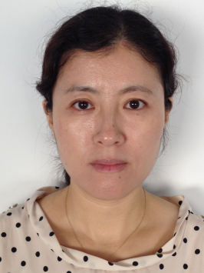

**Yi Guo**

Belonging

Chief Reviewer, Office of Medical Devices Ⅱ, Pharmaceuticals and Medical Devices Agency (PMDA)

Educational Background

* MD., Capital Medical University, BeiJing, China, 1996
* Ph.D. in Engineering, Nagaoka University of Technology, Niigata, Japan, 2004

Professional Experience

* 1996 Sep.～1998 Sep.

Chinese Rehabilitation Research Center(CRRC), as a neurologist in the

Neurology Department,

* 2004 Apr.～2008 Mar.

Paramount Bed Co., Ltd., as a researcher in the Research and Development Department,

* 2008 Apr.～

Pharmaceuticals and Medical Devices Agency (PMDA) , as a reviewer in the Office of Medical Devices Ⅱ



**Mark Goldberger**

Dr. Goldberger received his MD degree from the Columbia University College of

Physicians and Surgeons in New York and his MPH from George Washington University in Washington, DC. He completed his postgraduate training at the Presbyterian Hospital in New York and the Centers for Disease Control (CDC) in Atlanta. While working for the CDC he participated in the outbreak investigation of Legionnaires ’ disease in Philadelphia in 1976 and the Swine Flu Immunization Program and subsequent outbreak of Guillain-Barre syndrome in 1976-77. He is board certified in internal medicine and infectious disease and is a fellow of the Infectious Diseases Society of America. Dr. Goldberger was on the faculty of Columbia University for nine years.

Dr. Goldberger joined the Food and Drug Administration in 1989. At FDA he served as primary reviewer, medical team leader, Director of the Division of Special Pathogen and Immunologic Drug Products and Director of the Office of Antimicrobial Products within the Center for Drug Evaluation and Research (CDER) of the Food and Drug Administration (FDA). In addition to these positions he coordinated drug shortage activities within the CDER from 1990 - 2006. Dr. Goldberger also was the FDA lead in an assessment of the readiness of the Pharmaceutical Industry for Y2K. In 2000 he spent 8 months as acting Associate Center Director for Quality Assurance in CDER during which time he developed the concept of the Regulatory Briefing. In 2003-2004 he was Acting Deputy Center Director of CDER.

During much of his time at CDER he was heavily involved in the development of drugs for HIV, tuberculosis, influenza, malaria and drug resistant organisms. He has also worked with the FDA Center for Devices and Radiologic Health on nucleic acid amplification tests for tuberculosis and with the FDA Center for Veterinary Medicine on antimicrobial resistance issues as well as with other agencies and organizations on a broad range of issues related to infectious diseases. In 2006 he became Medical Director for Emerging and Pandemic Threat Preparedness within the Center for Biologics Evaluation and Research (CBER) of the Food and Drug Administration. In this position he has lead and coordinated multiple Center and Agency efforts in these areas.

In October 2007 he joined Abbott as Divisional Vice President – Regulatory Policy and Intelligence This position is a global function with staff located in Rockville, MD and Maidenhead, U.K. In this role he is involved in multiple areas of both product and policy development as well as participating in trade association and NGO activities related to anti-infective and tuberculosis drug development. As a member of the FDA Alumni Association he has participated in several training sessions for staff from CDE/SFDA.

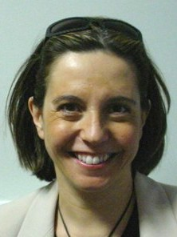

**Francesca Cerreta**

Qualified from the Universita’ degli Studi di Firenze (Italy) as a pharmaceutical chemist in 1992, and as a pharmacist in 2003. She worked as a research scientist at the CNRS laboratories in Caen (France) and subsequently for Merck in the field of molecular biology and for Eli Lilly in clinical research. In 1996 she joined the European Medicines Agency. At EMA she has covered different roles, as Scientific Administrator in the area of Quality of Medicines with focus on innovative technologies, in Scientific Advice, where she coordinated the establishment of the parallel scientific advice procedure, and in the CNS section of the Safety and Efficacy of Medicines. Since 2010 she has focused on the establishment and implementation of the EMA geriatric medicines initiative.

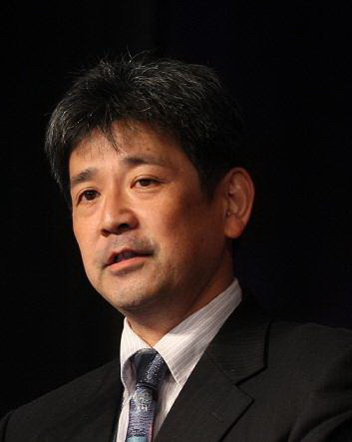

**Atsushi Tamura**

Dr. Atsushi Tamura, International Coordination officer for Medical Devices, Pharmaceuticals and Medical Devices Agency (PMDA), Japan. After, he joined MHW(MHLW), he dealt with post market safety measurements, medical device review and clinical trial consultation for drugs. In addition, he has an experience to stay a visiting researcher at CDER in US FDA in 1996-1997 and to be a visiting scholar at University of Southern California in 2002-2003. Currently he is a representative of Japanese regulatory agency for GHTF SC and SG1 and for IMDRF MC.

**I chun Lai**

**Education:**

Medical Department, Taipei Medical University

**Present:**

Team Leader, Center for Drug Evaluation

Medical Reviewer, Center for Drug Evaluation

**Experience:**

Attending Physician, Nephrology department, Taipei Medical University Hospital



**Shelley Tang**

Ms Tang holds a Bachelor of Applied Science, in Medical Technology, majoring in microbiology and histopathology. She retired from Australia’s Therapeutic Goods Administration in July 2011.

During her 25 years at the TGA, she held various positions, leading the assessment of sterile manufacture of medicines and devices, managing the program of testing of medical devices and supervising the Medical Device Incident Reporting and Investigation Scheme, and taking responsibility for the program of conformity assessment for medical devices. She also led the introduction of Australia’s new IVD regulatory scheme, introduced on 1 July 2010. At the time of leaving TGA, she held the position of Head of the Office of Devices Authorisation.

Prior to her retirement, she was Chair of the Global Harmonisation Task Force Study Group 1 sub-group on IVDs, and a member of the International Standards Organisation Technical Committee 212, developing standards for IVDs.

Ms Tang currently runs her own company, Stellar Consulting, providing consulting services both nationally and internationally on the regulation of medical devices, including IVD. She is a Subject Matter Expert with the World Medical Device Organisation, and in that capacity has developed on-line training courses on regulation of IVDs in Australia, and an introduction to the GHTF.

**Session D.**

**Critical Thinking and Decision Making : Drugs and Devices (Parallel Session)**

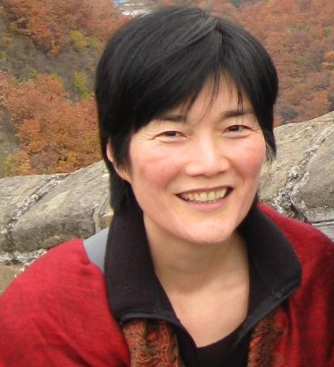

**Florence Houn**

Dr. Florence Houn is Celgene’s Vice President, Regulatory Policy and Strategy, having joined in August, 2008. Prior to this, she served 15 years in the US Food and Drug Administration (US FDA), most recently as Deputy Director for the Office of Vaccines Research and Review in the Center for Biologics Evaluation and Research (CBER). In recognition of her contributions to public health, Dr. Houn received the US Department of Health and Human Services’ Career Achievement Award in January 2009.

From 1999 to 2006, Dr. Houn was the Director, Office of Drug Evaluation III in the Center for Drug Evaluation and Research (CDER). She served as a Deputy Director for the Office of Drug Evaluation II in 1998, and from 1993-1998, was the Director for the Division of Mammography Quality and Radiation Programs in the FDA’s Center for Devices and Radiological Health (CDRH).

Dr. Houn is the co-chair of the FDA Alumni Association’s (FDAAA) International Network and a member of its Board of Directors. She was on the PDUFA V industry negotiating team with FDA in 2010-2011.

Dr. Houn received her Bachelor of Arts degree from Harvard University and her medical degree from the Albert Einstein College of Medicine. She completed her Cancer Prevention Fellowship at the National Cancer Institute and obtained her Masters of Public Health from the Johns Hopkins School of Hygiene and Public Health. She attended the Johns Hopkins Breast and Ovarian Surveillance Service as an Instructor in Oncology. She has served four years in the National Health Service Corps in a manpower health shortage area in East Baltimore.

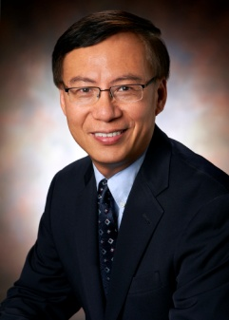

**Zili Li**

Dr. Li is currently Executive Director and Head of Emerging Market Regulatory Strategy and Liaison within Merck/MSD, overseeing regulatory strategy development for registering both innovative drug products and the drug products specifically developed for Emerging Markets. Also he serves as co-chair of US FDA Alumni Association International Network.

Dr. Li joined Merck in June 2005 as director of clinical research operation, Asia Pacific. One year later, he took an assignment in Beijing China as Director of MSD China regulatory policy and then in 2008 as the head of Asia Pacific regulatory policy. In Jan 2009, he became medical director of MSD China and in June 2010 as Emerging Market Regulatory Strategy and Policy Lead.

Prior to joining Merck, Dr. Li was a medical team leader with US FDA/CDER. Dr. Li, a graduate of Peking Union Medical College in Beijing China, completed his residency training at the Johns Hopkins. In addition to his medical degree, Dr. Li also held two master degrees in public health from Johns Hopkins School of Public Health and the graduate school of public health in San Diego California, respectively.



**Mark Goldberger**

Dr. Goldberger received his MD degree from the Columbia University College of

Physicians and Surgeons in New York and his MPH from George Washington University in Washington, DC. He completed his postgraduate training at the Presbyterian Hospital in New York and the Centers for Disease Control (CDC) in Atlanta. While working for the CDC he participated in the outbreak investigation of Legionnaires ’ disease in Philadelphia in 1976 and the Swine Flu Immunization Program and subsequent outbreak of Guillain-Barre syndrome in 1976-77. He is board certified in internal medicine and infectious disease and is a fellow of the Infectious Diseases Society of America. Dr. Goldberger was on the faculty of Columbia University for nine years.

Dr. Goldberger joined the Food and Drug Administration in 1989. At FDA he served as primary reviewer, medical team leader, Director of the Division of Special Pathogen and Immunologic Drug Products and Director of the Office of Antimicrobial Products within the Center for Drug Evaluation and Research (CDER) of the Food and Drug Administration (FDA). In addition to these positions he coordinated drug shortage activities within the CDER from 1990 - 2006. Dr. Goldberger also was the FDA lead in an assessment of the readiness of the Pharmaceutical Industry for Y2K. In 2000 he spent 8 months as acting Associate Center Director for Quality Assurance in CDER during which time he developed the concept of the Regulatory Briefing. In 2003-2004 he was Acting Deputy Center Director of CDER.

During much of his time at CDER he was heavily involved in the development of drugs for HIV, tuberculosis, influenza, malaria and drug resistant organisms. He has also worked with the FDA Center for Devices and Radiologic Health on nucleic acid amplification tests for tuberculosis and with the FDA Center for Veterinary Medicine on antimicrobial resistance issues as well as with other agencies and organizations on a broad range of issues related to infectious diseases. In 2006 he became Medical Director for Emerging and Pandemic Threat Preparedness within the Center for Biologics Evaluation and Research (CBER) of the Food and Drug Administration. In this position he has lead and coordinated multiple Center and Agency efforts in these areas.

In October 2007 he joined Abbott as Divisional Vice President – Regulatory Policy and Intelligence This position is a global function with staff located in Rockville, MD and Maidenhead, U.K. In this role he is involved in multiple areas of both product and policy development as well as participating in trade association and NGO activities related to anti-infective and tuberculosis drug development. As a member of the FDA Alumni Association he has participated in several training sessions for staff from CDE/SFDA.

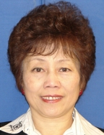

**Chi-wan Chen**

Chi-wan Chen is Executive Director in Global CMC, Pfizer, responsible for regulatory CMC policies and strategies with a focus on Asia Pacific. She chairs the Asia Pacific Focus Group under the International Society of Pharmaceutical Engineering (ISPE), and serves as an ad hoc CMC advisor to the China R&D-based Pharmaceutical Association Committee (RDPAC) and to the Association of South East Asia Nations (ASEAN) Pharmaceutical Research Industry Association (APRIA). Dr. Chen has made numerous presentations on regulatory and CMC topics in Asia Pacific.

Prior to joining Pfizer in 2008, Dr. Chen had served in the U.S. FDA for more than 21 years and held several management positions in the Center for Drug Evaluation and Research (CDER), including Deputy Director in the Office of New Drug Quality Assessment (ONDQA). She represented CDER on the ICH Q1AR, Q3AR/Q3BR, and Q8R Expert Working Groups (EWGs) between 1998 and 2008. Dr. Chen is currently an active member of the Food and Drug Administration (FDA) Alumni Association International Network (FDAAAIN). She has a Ph.D. degree in organic chemistry from the University of Wisconsin, U.S.A.

**I chun Lai**

**Education:**

Medical Department, Taipei Medical University

**Present:**

Team Leader, Center for Drug Evaluation

Medical Reviewer, Center for Drug Evaluation

**Experience:**

Attending Physician, Nephrology department, Taipei Medical University Hospital

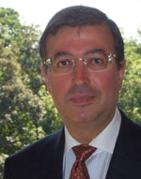

**Laurent Selles**

Laurent SELLES is in charge of international relations for the Health Technology and Cosmetics Unit of the Directorate General Health and Consumers of the European Commission.

He graduated from the ‘Physics and Chemistry School of Paris’ (including research at Northeastern University, Boston, USA) and from the University of Paris VII with an Advanced Studies Degree in ‘Physics of Energy’.

After 12 years in the automotive industry in R&D activities, he joined the European Commission to launch the Polis/Telecities network of European cities.

In 1996 he contributed to the EU legislation relating to automotive construction on safety and environmental issues as a deputy head of unit. He then joined the Cosmetics and Medical Devices unit as a deputy head of unit all policy and international issues regarding public safety.

Laurent SELLES is in charge of the international cooperation with bilateral dialogues between the EU and its main trading partners and in multilateral frameworks (such as the Global Harmonization Task Force for Medical Devices GHTF, the International Medical Device Regulators' Forum IMDRF and the International Cooperation on Cosmetics' Regulation ICCR). In this respect, after ensuring the coordination with the health ministries of the Member States, he represents the European position at the steering committees of GHTF, IMDRF and ICCR. He also chairs the GHTF/IMDRF working group on Unique Device Identification (UDI) with the aim of permitting traceability at an international level.



**Yi Guo**

Belonging

Chief Reviewer, Office of Medical Devices Ⅱ, Pharmaceuticals and Medical Devices Agency (PMDA)

Educational Background

* MD., Capital Medical University, BeiJing, China, 1996
* Ph.D. in Engineering, Nagaoka University of Technology, Niigata, Japan, 2004

Professional Experience

* 1996 Sep.～1998 Sep.

Chinese Rehabilitation Research Center(CRRC), as a neurologist in the

Neurology Department,

* 2004 Apr.～2008 Mar.

Paramount Bed Co., Ltd., as a researcher in the Research and Development Department,

* 2008 Apr.～

Pharmaceuticals and Medical Devices Agency (PMDA) , as a reviewer in the Office of Medical Devices Ⅱ



**Shelley Tang**

Ms Tang holds a Bachelor of Applied Science, in Medical Technology, majoring in microbiology and histopathology. She retired from Australia’s Therapeutic Goods Administration in July 2011.

During her 25 years at the TGA, she held various positions, leading the assessment of sterile manufacture of medicines and devices, managing the program of testing of medical devices and supervising the Medical Device Incident Reporting and Investigation Scheme, and taking responsibility for the program of conformity assessment for medical devices. She also led the introduction of Australia’s new IVD regulatory scheme, introduced on 1 July 2010. At the time of leaving TGA, she held the position of Head of the Office of Devices Authorisation.

Prior to her retirement, she was Chair of the Global Harmonisation Task Force Study Group 1 sub-group on IVDs, and a member of the International Standards Organisation Technical Committee 212, developing standards for IVDs.

Ms Tang currently runs her own company, Stellar Consulting, providing consulting services both nationally and internationally on the regulation of medical devices, including IVD. She is a Subject Matter Expert with the World Medical Device Organisation, and in that capacity has developed on-line training courses on regulation of IVDs in Australia, and an introduction to the GHTF.

**Jai-Yen Chen**

Work Experience:

Division of Medical Devices, Center For Drug Evaluation, Taiwan                Reviewer 2010/05-present

Center for Cardiovascular Technology, Standard University, US

Visiting Scholar 2009/05-2010/10

Division of Medical Devices, Center For Drug Evaluation, Taiwan                Reviewer 2006/02-2009/05

Education:

Imperial College, UK  Department of Biology  Ph.D.

**Session E.**

**Transparency and Interactions: With the Public, Industry/Other Stakeholders and Regulatory Authorities**

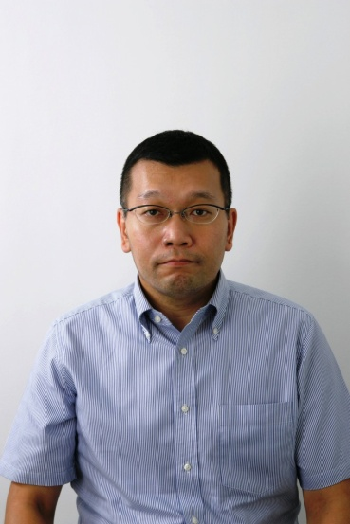

**Naoyuki Yasuda**

Mr. Naoyuki Yasuda, International Planning Director, Minister’s Secretariat, Ministry of Health, Labour and Welfare, Japan, was born and raised in Hokkaido. He graduated from the Faculty of Pharmaceutical Science, Osaka University in 1991.

He joined Ministry of Health and Welfare (former MHLW) in 1991 and began his career at Guidance and Inspection Division, Pharmaceutical Affairs Bureau. He was careered in Ministry of International Trade and Industry for Space industry issue in 1995, Administrator, Organization of Economics, Cooperation and Development (OECD) for the hazard assessment of existing chemicals in 1998, Deputy Director, Office of Medical Devices Evaluation, Pharmaceutical and Food Safety Bureau, MHLW in 2003, 1st Secretary, Permanent Mission of Japan to the International Organizations in Vienna for international cooperation on Narcotics and pychotropics in 2005, and Planning Director, Blood and Blood Products Division, Pharmaceutical and Food Safety Bureau, MHLW for blood safety and vaccines supply in 2010.

He has taken his position as International Planning Director, MHLW from August 2011.

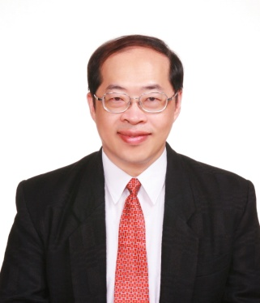

**Herng-Der Chern**

Name: **Herng-Der Chern, M.D., Ph.D.**

Title: Distinguished Research Fellow

Affiliation: Center for Drug Evaluation, Chinese Taipei

Contact Information: [hdchern@cde.org.tw](mailto:hdchern@cde.org.tw)

**Biography**

Dr. Chern received his M.D. degree from National Taiwan University in 1983 and his Ph.D. degree in pharmacology from University of Pittsburgh in 1994. Before he joined Center for Drug Evaluation in 1998, Dr. Chern was the head of Division of Clinical Pharmacology of National Taiwan University Hospital and associate professor in National Taiwan University. Until March 2011, Dr. Chern had been the Executive Director of Center for Drug Evaluation and in charge of technical review of IND/NDA/HTA for Taiwan’s government. Under his leadership, Center for Drug Evaluation is one of a few regulatory agencies in Asia that can perform in-house review based on good regulatory science.

In the last 14 years, Dr. Chern plays a very active role in promoting ICH concept, GCP education, good review practice, bridging study, new drug development and Health Technology Assessment in Asia. Dr. Chern served as the APEC representative for the ICH-GCG group in ICH 5 and ICH 6.

Dr. Chern involved in many regional harmonization initiatives especially the APEC Network of Pharmaceutical Regulatory Science leaded by Taiwan since 2000 and APEC Best Regulatory Practice Project since 2011. Not only serving as a speaker and session chair in many DIA conferences, Dr. Chern was also the guest editor for four issues, focused on the current status of infrastructure and regulatory science of new drug development in Asia, for Drug Information Journal in 1998, 2003 and 2009. Dr. Chern is the winner of 2006 DIA Outstanding Service Award for his contribution to DIA.



**Laurent Selles**

Laurent SELLES is in charge of international relations for the Health Technology and Cosmetics Unit of the Directorate General Health and Consumers of the European Commission.

He graduated from the ‘Physics and Chemistry School of Paris’ (including research at Northeastern University, Boston, USA) and from the University of Paris VII with an Advanced Studies Degree in ‘Physics of Energy’.

After 12 years in the automotive industry in R&D activities, he joined the European Commission to launch the Polis/Telecities network of European cities.

In 1996 he contributed to the EU legislation relating to automotive construction on safety and environmental issues as a deputy head of unit. He then joined the Cosmetics and Medical Devices unit as a deputy head of unit all policy and international issues regarding public safety.

Laurent SELLES is in charge of the international cooperation with bilateral dialogues between the EU and its main trading partners and in multilateral frameworks (such as the Global Harmonization Task Force for Medical Devices GHTF, the International Medical Device Regulators' Forum IMDRF and the International Cooperation on Cosmetics' Regulation ICCR). In this respect, after ensuring the coordination with the health ministries of the Member States, he represents the European position at the steering committees of GHTF, IMDRF and ICCR. He also chairs the GHTF/IMDRF working group on Unique Device Identification (UDI) with the aim of permitting traceability at an international level.



**Yow Soh Zoem**

Soh Zeom obtained her PhD in Bioengineering and is currently a Regulatory Specialist with the Health Sciences Authority Singapore. She is an evaluator of general and in-vitro diagnostic medical devices.



**Mike Ward**

Mike Ward joined Health Canada in 1986 following nine years industrial experience in the QA/QC area. Since that time he has held a variety of regulatory positions including GMP specialist, premarket Quality reviewer and manager, and senior policy analyst. Mike is Manager of the International Programs Division of the Therapeutic Products Directorate of Health Canada. He served as the Canadian Observer to the ICH Steering Committee and a former regulatory co-chair of the Global Cooperation Group. He chairs the Regulatory Harmonization Steering Committee of the APEC Life Sciences Innovation Forum and is an alternate representative for NAFTA on the PanAmerican Regulatory Harmonization Steering Committee.



**Francesca Cerreta**

Qualified from the Universita’ degli Studi di Firenze (Italy) as a pharmaceutical chemist in 1992, and as a pharmacist in 2003. She worked as a research scientist at the CNRS laboratories in Caen (France) and subsequently for Merck in the field of molecular biology and for Eli Lilly in clinical research. In 1996 she joined the European Medicines Agency. At EMA she has covered different roles, as Scientific Administrator in the area of Quality of Medicines with focus on innovative technologies, in Scientific Advice, where she coordinated the establishment of the parallel scientific advice procedure, and in the CNS section of the Safety and Efficacy of Medicines. Since 2010 she has focused on the establishment and implementation of the EMA geriatric medicines initiative.



**Herng-Der Chern**

Name: **Herng-Der Chern, M.D., Ph.D.**

Title: Distinguished Research Fellow

Affiliation: Center for Drug Evaluation, Chinese Taipei

Contact Information: [hdchern@cde.org.tw](mailto:hdchern@cde.org.tw)

**Biography**

Dr. Chern received his M.D. degree from National Taiwan University in 1983 and his Ph.D. degree in pharmacology from University of Pittsburgh in 1994. Before he joined Center for Drug Evaluation in 1998, Dr. Chern was the head of Division of Clinical Pharmacology of National Taiwan University Hospital and associate professor in National Taiwan University. Until March 2011, Dr. Chern had been the Executive Director of Center for Drug Evaluation and in charge of technical review of IND/NDA/HTA for Taiwan’s government. Under his leadership, Center for Drug Evaluation is one of a few regulatory agencies in Asia that can perform in-house review based on good regulatory science.

In the last 14 years, Dr. Chern plays a very active role in promoting ICH concept, GCP education, good review practice, bridging study, new drug development and Health Technology Assessment in Asia. Dr. Chern served as the APEC representative for the ICH-GCG group in ICH 5 and ICH 6.

Dr. Chern involved in many regional harmonization initiatives especially the APEC Network of Pharmaceutical Regulatory Science leaded by Taiwan since 2000 and APEC Best Regulatory Practice Project since 2011. Not only serving as a speaker and session chair in many DIA conferences, Dr. Chern was also the guest editor for four issues, focused on the current status of infrastructure and regulatory science of new drug development in Asia, for Drug Information Journal in 1998, 2003 and 2009. Dr. Chern is the winner of 2006 DIA Outstanding Service Award for his contribution to DIA.

**Session F.**

**Conclusion**



**Mike Ward**

Mike Ward joined Health Canada in 1986 following nine years industrial experience in the QA/QC area. Since that time he has held a variety of regulatory positions including GMP specialist, premarket Quality reviewer and manager, and senior policy analyst. Mike is Manager of the International Programs Division of the Therapeutic Products Directorate of Health Canada. He served as the Canadian Observer to the ICH Steering Committee and a former regulatory co-chair of the Global Cooperation Group. He chairs the Regulatory Harmonization Steering Committee of the APEC Life Sciences Innovation Forum and is an alternate representative for NAFTA on the PanAmerican Regulatory Harmonization Steering Committee.

**Churn-Shiouh Gau**

|  |  |  |
| --- | --- | --- |
| **CURRICULUM VITAE** | | |
| **Churn-Shiouh Gau, Ph.D.** | | D:\高老師\個人\高老師大頭照.jpg |
| **CONTACT INFORMATION** | |
| (E-mail) csgau206@cde.org.tw | |
| (TEL) +886-2-8170-6000 ext. 101 | |
| (Address) 3F, No.465, Sec.6, Zhongxiao E. Rd. | |
| Taipei 11557, Taiwan | | |
| **ACADEMIC QUALIFICATIONS** | | |
| (years) | (degrees) | |
| 1989-1992 | PhD in Pharmaceutics/School of pharmacy, University of Wisconsin-Madison, USA | |
| 1987-1989 | MS in Pharmaceutics/School of pharmacy, University of Wisconsin-Madison, USA | |
| **PRESENT APPOINTMENTS** | | |
| (years) | (positions) | |
| 2011~ | Researcher/Center of Science and Technology, Food and Drug Administration, Department of Health, Executive Yuan, Taiwan | |
| 2011~ | Executive Director/Center for Drug Evaluation, Taiwan | |
| **PREVIOUS APPOINTMENTS** | | |
| (years) | (positions) | |
| 1992-2011 | Associate Professor/School of Pharmacy & Graduate Institute of Clinical Pharmacy, National Taiwan University | |
| 2006-2009 | Deputy Executive Director/Center for Drug Evaluation | |
| 2003-2011 | Expert and Committee Member for Drug Review Committee, Department of Health, Executive Yuan | |
| 1996-2000 | Director/Department of Pharmacy, National Taiwan University Hospital | |
| 1985-1992 | Lecturer, School of Pharmacy, National Taiwan University | |
| 1981-1985 | Teaching Assistant, School of Pharmacy, National Taiwan University | |
| **RESEARCH INTERESTS** | | |
| Pharmaceutics, Interfacial Phenomena, Pharmaceutical Affairs, Pharmacoepidemiology, Drug safety monitoring | | |

**Closing Remarks**