ICH HARMONISED GUIDELINE
ICH M12: Drug Interaction Studies
(Draft version, Endorsed on 24 May 2022)
指引意見彙整表
段落 | 標題 | 內文 (摘自M12 draft guideline，仍以ICH文件為準) | 相關建議及意見  (請提供中英文內容)
1. INTRODUCTION
 | 1.1 Objective | This guideline provides recommendation to promote a consistent approach in designing, conducting, and interpreting enzyme- or transporter-mediated in vitro and clinical drug-drug interaction (DDI) studies during the development of a therapeutic product. A consistent approach will reduce uncertainty for pharmaceutical industry to meet the requirement of multiple regulatory agencies and lead to more efficient utilization of resources.
 | 1.2 Background | In clinical practice, patients are often prescribed more than one drug which can result in a DDI. Some patients, in particular fragile older patients or patients with serious or multiple health issues, can be prescribed a large number of different drugs (i.e., polypharmacy). The occurrence of DDIs is a common clinical problem that can increase the risk of adverse events, sometimes leading to hospital admissions. Alternatively, some DDIs can reduce treatment efficacy. Hence, it is important to consider an investigational drug’s potential to interact with other drugs.  Regional guidelines for investigations of DDIs have been available for decades and have undergone several updates as scientific progress has been made. In general, the proposed approach to the investigation of interaction potential of investigational new drugs has been similar between regions, but despite harmonization initiatives, some differences have remained. This ICH guideline aims to harmonize recommendations for in vitro and clinical evaluation of DDIs.  This guideline provides general recommendations on how to evaluate the DDI potential of an investigational drug. It is recognized that the DDI evaluation is generally tailored based on the specific drug, intended patient population, and therapeutic context. Alternative approaches can be used if they satisfy the requirements of the applicable statutes and regulations. The focus of the guideline is the development of new drugs, but if new scientific information regarding the potential for DDIs is obtained after drug approval, additional DDI evaluation should be considered.
 | 1.3 Scope | The scope of the guideline is limited to pharmacokinetic interactions, with a focus on enzyme- and transporter-mediated interactions. These aspects in general apply to the development of small chemical molecules. DDI evaluation of biologics is only covered briefly, with focus on monoclonal antibodies and antibody-drug conjugates. Guidance is provided on how to investigate interactions mediated by inhibition or induction of enzymes or transporters, both in vitro and in vivo, and on how to translate the results to appropriate treatment recommendations. The guideline also includes recommendations on how to address metabolite-mediated interactions. The use of model-based data evaluation and DDI predictions are also covered.  Other types of pharmacokinetic interactions, e.g., regarding impact on absorption (e.g., gastric pH change, gastric motility change, formation of chelation or complexation, etc.), food effects, or protein binding displacement, are not part of this document and may be covered by regional guidelines. Similarly, DDIs that are a result of pharmacodynamic interactions are beyond the scope of this guideline.
 | 1.4 General Principles | The potential for an investigational drug to cause DDIs should be investigated in a stepwise manner during drug development. The potential for a new drug to cause pharmacokinetic interactions both as a victim (effect of other drugs on the investigational drug) and as a perpetrator (effect of the investigational drug on concomitant drugs) should be evaluated. All aspects mentioned below are further expanded and discussed later in the document.  Evaluating the potential of an investigational drug as a victim of a metabolic enzyme- or transporter-mediated DDI involves identification of the principal routes of the drug’s elimination. For drugs that are not eliminated predominantly unchanged in urine or that are not biologics eliminated through unspecific catabolism, the keystone of the identification of principal elimination routes is a well performed clinical mass balance study. In some instances, e.g., if a large part of the dose is found as unchanged drug in feces, an absolute bioavailability study can also be a useful complement to aid interpretation. Using data from the mass balance study, the quantitative contributions of the different elimination pathways should be estimated based on the amount of dose excreted as primary and secondary metabolites along specific routes. For quantitatively important elimination pathways, in vitro and clinical studies should be used to identify the main enzymes or transporter proteins involved in these pathways. The ability to predict  interactions affecting the investigational drug is dependent on the identification of these proteins.  Evaluating the DDI potential of an investigational drug as a perpetrator, involves characterizing the effect of the drug on enzymes and transporters. This evaluation often starts with in vitro experiments to elucidate potential DDI mechanisms. Identification of DDI risks should then be followed by clinical DDI studies based on mechanistic knowledge, and the results should be translated to appropriate clinical management recommendations for drugs as a victim and  perpetrator of DDIs.  The results of DDI evaluations inform the protocols for clinical studies in patients regarding the use of concomitant drugs. Information about the interaction potential should be gained as early in drug development as practically possible to assure safety and avoid unnecessary restrictions of concomitant medications and/or exclusion of patients who require the concomitant medications in clinical studies, typically phase 2/3 studies. The timing of the different non-clinical and clinical studies is dependent on the context and type of product; some general recommendations are given below. Predictive modeling (see Section 7.3) can also assist evaluation of the DDI potential.  - In vitro data on the investigational drug as a substrate of metabolic enzymes generally should be obtained before starting phase 1 (first-in-human) to evaluate metabolic stability and identify the potential main metabolic pathway(s) and enzyme(s) that metabolize the investigational drug (reaction phenotyping studies). If in vitro studies suggest the possibility of clinically significant interaction with inhibitors or inducers of a metabolic enzyme, it is preferable that dedicated clinical DDI studies be conducted prior to studies in patients. Until studies are conducted, a conservative strategy, such as excluding patients on certain concomitant drugs that are inhibitors or inducers, may be needed.  - The results of the mass balance study should generally be available before starting phase 3. Based on results of the mass balance study and in vitro studies, clinical studies with strong index enzyme inhibitors and inducers should be considered to confirm and quantify the main metabolism pathways and define the risk for clinically significant DDIs.  - ADME (absorption, distribution, metabolism, and excretion) properties determine whether in vitro data of the investigational drug as a substrate for transport proteins should be collected. If a drug has limited absorption or is expected to undergo significant active hepatic uptake, biliary excretion or active renal secretion as unchanged drug, the relevant transporters should be identified in vitro before initiating clinical studies in patients to avoid protocol restrictions.  - In vitro data on the effects of the investigational drug as a perpetrator on the major cytochrome P450 (CYP) enzymes and transporters should generally be available before administering the drug to patients.  - The pharmacokinetic DDI potential of metabolites with significant plasma exposure or pharmacological activity should be considered similarly as for the parent drug, but these investigations can generally be completed later in development when more knowledge about the exposure and activity of metabolites is available.
2. IN VITRO EVALUATION
 | 2.1 Evaluation of Metabolism-Mediated Interactions | In vitro studies are important first steps to identify risks for a drug to be a victim or perpetrator for DDIs through inhibition or induction of drug metabolizing enzymes.  2.1.1 Drug as a Substrate of Metabolizing Enzymes  Typically, an in vitro screening to identify the main enzymes responsible for the metabolism of a new drug is performed early in drug development. If the mass-balance study suggests metabolism as an important elimination mechanism for the drug, enzymes involved in metabolic pathways which based on the mass-balance study are estimated to contribute to ≥ 25% of drug elimination should normally be identified. This applies to CYP enzymes as well as non-CYP enzymes.  If oxidative metabolism is important, the identification of catalyzing enzymes usually starts by determining whether the investigational drug is an in vitro substrate for the most common CYP enzymes involved in drug metabolism: CYP1A2, CYP2B6, CYP2C8, CYP2C9, CYP2C19, CYP2D6, and CYP3A using in vitro phenotyping experiments. If the drug is not found to undergo significant metabolism by these major CYP enzymes, other enzymes can be investigated. These additional enzymes can include, but are not limited to:  - Other CYP enzymes, including CYP2A6, CYP2E1 CYP2J2, and CYP4F2 Other phase 1 enzymes, including alcohol/aldehyde dehydrogenase (ADH/ALDH), aldehyde oxidase (AO), carboxylesterase (CES), flavin monooxygenase (FMO), monoamine oxidase (MAO), and xanthine oxidase (XO).  - Phase 2 enzymes: The most frequently evaluated, Uridine 5’-diphospho-glucuronosyltransferase (UDP-glucuronosyl transferases (UGTs)), are responsible for glucuronide conjugation of drugs and metabolites. A phenotyping study is recommended for an investigational drug if it is mainly eliminated by direct glucuronidation. The following UGTs play a role in metabolism of certain drugs: UGT1A1, 1A3, 1A4, 1A6, 1A9, 1A10, 2B4, 2B7, 2B10, 2B15, and 2B17 (1).  - Other phase 2 enzymes, including glutathione S-transferases (GSTs), N-acetyltransferases (NATs), sulfotransferases (SULTs).  Details on the experimental setup for in vitro studies to identify enzymes catalyzing the main elimination pathways are given in Sections 7.1.1 and 7.1.2.  When the candidate enzymes have been identified in vitro, the main metabolic pathways (≥25% of total elimination) generally require additional clinical characterization to determine and quantify the risk of interaction with the investigational drug as a victim. This is normally done by performing clinical DDI studies using a strong index inhibitor of the enzyme. For some enzymes, pharmacogenetic studies can substitute for clinical DDI studies (refer to Section 4.1). A clinical study with a strong inducer is also generally conducted, since inducers often up-regulate expression of multiple enzymes and transporters (except CYP2D6, which is generally considered not inducible by drugs).  2.1.2 Drug as an Inhibitor of CYP Enzymes  An investigational drug’s potential to inhibit CYP1A2, CYP2B6, CYP2C8, CYP2C9, CYP2C19, CYP2D6, and CYP3A in both a reversible manner (i.e., as reversible inhibitor) and time-dependent manner (i.e., as time-dependent inhibitor (TDI)) should be evaluated. Investigation of potential inhibition of UGT enzymes is further discussed in Section 2.1.3. For details on the experimental setup for these experiments, refer to Sections 7.1.1 and 7.1.3.  2.1.2.1 Reversible Inhibition  In the reversible inhibition experiments, a K_{i} (inhibition constant) is usually determined experimentally or estimated based on half-maximal inhibitory concentration (IC₅₀) (refer to Section 7.1.3). If the initial experiments testing a sufficiently high concentration of the investigational drug already indicate that the Ki will be markedly higher than the cutoffs given (see below), the risk for clinical inhibition can normally be excluded without further data.  The risk for reversible enzyme inhibition can be excluded based on in vitro data (“basic method”) if  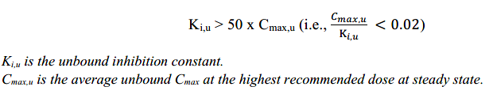  Considering uncertainties in protein binding measurements for highly bound drugs, i.e., >99% protein binding, f_{u,p} (fraction unbound in plasma) should be set at 0.01 (i.e. 1%). It is understood that there have been advances in methodologies to measure f_{u,p} for highly protein bound drugs, and this is an area of active research. Hence, in some situations, the measured f_{u,p} can be used if the accuracy and precision of measurement is demonstrated. Such a demonstration should include full validation data of the protein binding assay including bioanalytical method with appropriate positive controls (i.e., drugs with high binding to relevant plasma proteins). Demonstration of reproducible findings with different assays (e.g., ultrafiltration, equilibrium dialysis, ultracentrifugation) increases the reliability of the f_{u,p} measurement and is preferred. This consideration for f_{u,p} applies in other contexts where basic method, mechanistic static, and dynamic models (often referred as physiologically based pharmacokinetic (PBPK) modeling) can be used to interpret the in vitro results of enzyme and transporter inhibition/induction experiments.  For orally administered drugs that are inhibitors of CYP3A, the risk of intestinal CYP3A inhibition can be excluded if  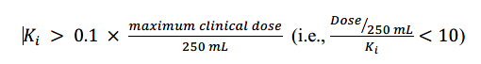  If risk for clinical inhibition cannot be excluded using this basic method, mechanistic static and/or PBPK models can be used to interpret the in vitro experiment results (refer to Section 7.3). If in vitro data and modeling do not exclude the risk for clinical inhibition, a clinical DDI study with a sensitive index substrate should be conducted.  If a clinical study using a substrate for an enzyme that was inhibited in vitro by an investigational drug with a low Ki shows lack of inhibition, then the risk for clinical inhibition can be excluded for other enzymes having a larger Ki. Such an inference should be made only for the enzymes that are expressed at the same site and for which the inhibition potencies are determined in the same experiment (rank order approach) (2, 3). Of note, an orally administered drug can inhibit intestinal metabolic enzymes (e.g., CYP3A) in addition to hepatic enzymes. In such situations, the risk for inhibition of CYP3A in the gastrointestinal (GI) tract should be considered even if systemic inhibition of CYP3A can be excluded using the rank order approach based on a negative clinical study on another CYP enzyme. In the presence of inhibitory metabolites of an investigational drug, their contribution should also be considered when using rank order approach to determine if clinical studies should be conducted.  2.1.2.2 Time-Dependent Inhibition  If an in vitro assay (described in Section 7.1.3) indicates an increased enzyme inhibition potential with drug pre-incubation, the following equation can be used as the basic method to evaluate the risk for TDI (4-6). The risk for in vivo inhibition can be excluded based on in vitro data if  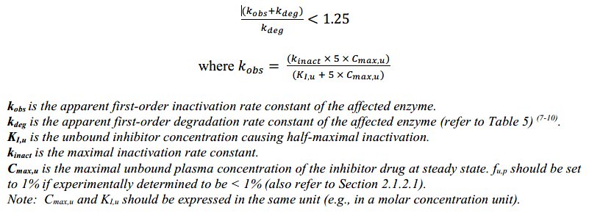  If the above ratio is ≥ 1.25, mechanistic static and/or PBPK models can be used to interpret the in vitro experiment results (refer to Section 7.3). If in vitro data and modeling do not exclude the risk for clinical inhibition, a clinical DDI study with a sensitive index substrate should be conducted. The rank order approach, mentioned above for reversible inhibitors, does not apply to TDIs.  2.1.3 Drug as an Inhibitor of UGTs  It is recognized that a drug which is not a substrate of an enzyme can still be an inhibitor. However, considering the generally limited magnitude of UGT inhibition-mediated DDIs, a routine evaluation of investigational drugs to inhibit UGTs may not be warranted. If direct glucuronidation is one of the major elimination pathways of an investigational drug, it is recommended to study in vitro whether the drug can inhibit UGTs including UGT1A1 and UGT2B7. The evaluation is usually performed using recombinant UGTs or human liver microsome (HLM) with relatively selective substrates (refer to Table 8, Section 7.4.2.1 for an illustrative list of substrates). When an investigational drug is to be used with another drug that is mainly metabolized by direct glucuronidation, it is recommended to evaluate the in vitro potential inhibitory effect of the investigational drug on the UGT isoform(s) responsible for the elimination of the other drug.  2.1.4 Drug as an Inducer of CYP Enzymes  An investigational drug’s potential to induce enzymes via activation of nuclear receptors pregnane X receptor (PXR), constitutive androstane receptor (CAR), aryl hydrocarbon receptor (AhR), and if relevant other drug regulation pathways, should be evaluated. For technical advice on the experiments, refer to Section 7.1.4.  To assess the DDI liability of a drug as an inducer, studies should be performed in human hepatocytes from at least 3 individual donors and the extent of enzyme induction should be measured at mRNA level. The enzymes CYP3A4, CYP2B6 and CYP1A2 should always be included as markers of induction mediated via PXR/CAR (CYP3A4, CYP2B6) and AhR (CYP1A2). Induction of other enzymes via these pathways can be studied in vitro but sometimes it is challenging to obtain satisfactory sensitivity to get a conclusive result. For CYP2C19, the mRNA responses to inducers are often limited (11, 12), and thus the activity should be measured using a probe substrate to evaluate the CYP2C19 induction potential of the investigational drug.  If the in vivo induction potential of CYP3A4 enzymes by an investigational drug can be excluded based on in vitro results, evaluating the induction potential of a drug on CYP2C enzymes is not necessary because both CYP3A4 and CYP2C enzymes are induced via activation of the PXR, and CYP2Cs are generally less inducible compared to CYP3A4.  If the investigational drug induces CYP3A4 in vitro, and the results suggest that a clinical study should be conducted, the potential of the investigational drug to induce CYP2Cs should be evaluated in vitro and/or in vivo. Alternatively, a negative clinical study with a sensitive CYP3A substrate can be used to rule out the induction potential of an investigational drug on CYP2C enzymes if the potential of CYP3A inhibition by the drug and its metabolite(s) can be excluded via in vitro and/or in vivo evaluation.  As described below, there are several methods that can be used to interpret mRNA data from in vitro induction experiments and to assess the in vivo potential of a drug to induce enzymes. It is recommended to first use the basic qualitative method (mRNA fold-change). If the basic method indicates induction potential, the evaluation can continue using more quantitative approaches (e.g., correlation methods) provided it is possible to study a wide range of concentrations of the investigational drug to determine induction parameters (e.g., E_{max} and EC₅₀). For the more quantitative approaches, one well-performing, qualified batch of hepatocytes is sufficient. The basic method only uses in vitro data from the investigational drug, whereas correlation methods compare the induction response of the drug to that of multiple established clinical inducers of the enzyme of interest.  In addition, mechanistic static or PBPK models can potentially be used (refer to Section 7.3). If a risk for induction cannot be excluded based on in vitro data and modeling, clinical studies with sensitive substrates of the enzymes of interest should be conducted.  2.1.4.1 Basic ‘mRNA Fold-Change’ Method  The induction results should be evaluated separately for each donor. The levels of mRNA should be compared to the control (vehicle) incubations, and a fold-change over the vehicle control should be calculated. In vivo induction potential cannot be excluded if the drug in hepatocytes from at least one donor meets the following criteria, and further evaluation of the induction potential should be conducted:  - increases mRNA expression of a CYP enzyme in a concentration-dependent manner; and  - the fold-change of CYP mRNA expression is ≥ 2-fold at 15× C_{max,u} (f_{u,p} = 0.01, if experimentally determined to be < 1%; also refer to Section 2.1.2.1).  In addition, the induction potential cannot be ruled out for an investigational drug that increases CYP enzyme mRNA less than 2-fold of the vehicle control but more than 20% of the response of the positive control. Further evaluation is recommended when there is an inconclusive finding, e.g., conducting in vitro testing with hepatocyte from another donor that has ≥6-fold mRNA increase of the CYP enzyme by a positive control.  To calculate the percent of the response to the positive control, the following equation should be used:  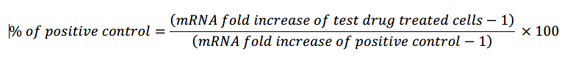  2.1.4.2 Correlation Methods  Correlation methods compare the induction effect of the investigational drug to that of established clinical inducers of the enzyme of interest (13-15). The magnitude of a clinical induction effect (e.g., area under the curve (AUC) ratio of sensitive substrate in the presence and absence of inducers) of an investigational drug is predicted based on a calibration curve of relative induction scores (RIS, see equation below) or C_{max,u}/EC₅₀ versus the in vivo induction effect for a set of known inducers of the same enzyme (also refer to Section 7.1.4). If the predicted AUC ratio > 0.8, the analysis can be used to exclude the risk for in vivo induction.  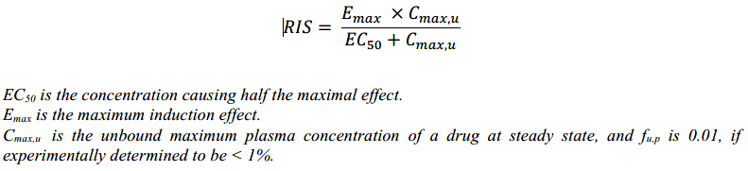  Sometimes, E_{max} or EC₅₀ cannot be estimated due to an incomplete in vitro induction profile (e.g., limited by solubility or cytotoxicity of tested drug). An alternative correlation approach can be used if the method is validated (16).  2.1.4.3 Basic Kinetic Model  Mechanistic models have been proposed to predict the sum of different interaction processes (reversible inhibition, TDI, induction) systemically as well as in the GI tract (17). This approach is further discussed in Section 7.3.  A limited version of this approach is described as below (18, 19). If R > 0.8, the analysis can be used to exclude the risk for in vivo induction.  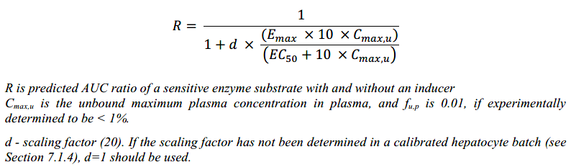  If the above methods indicate that the investigational drug has the potential to induce metabolizing enzymes (using specific cutoff values mentioned above or developed by individual laboratories for these methods), the enzyme induction potential of the investigational drug should be further investigated by conducting a clinical DDI study with a sensitive index substrate or using mechanistic models (refer to Sections 7.3).  2.1.4.4 Additional Considerations Related to Induction  In vitro induction studies can also detect enzyme down-regulation. However, research in this area is presently very limited, and the mechanisms behind these effects are unclear (11). If concentration-dependent down-regulation is observed in vitro and is not attributable to cytotoxicity, additional in vitro or clinical studies can be considered to understand the potential clinical consequences.
 | 2.2 Evaluation of Transporter-Mediated Interactions | 2.2.1 Drug as a Substrate of Transporters  P-glycoprotein (P-gp) and breast cancer resistance protein (BCRP) are efflux transporters expressed in the GI tract and can affect oral bioavailability of drugs. Thus, the possibility of being a substrate of P-gp and/or BCRP is often evaluated in vitro for investigational drugs given orally. Because P-gp and BCRP are also expressed in the liver and kidneys, in vitro study should be considered for a drug if biliary excretion or active renal secretion is likely to be a major elimination pathway of the drug. In addition, if the pharmacological target of the drug is in the brain, evaluating the drug as a substrate of P-gp and BCRP can help determine whether the drug penetrates into the brain (21).  Organic anion transporting polypeptide (OATP)1B1 and OATP1B3 are important hepatic uptake transporters that often mediate transport of compounds containing anionic group under physiological pH of systemic circulation. Examination of whether an investigational drug is a substrate for OATP1B1 and 1B3 should be considered if hepatic metabolism or biliary excretion accounts for ≥25% of elimination of a drug or if the pharmacological target of a drug is in the liver.  Organic anion transporter (OAT)1, OAT3, and Organic cation transporter (OCT)2 are renal uptake transporters. Multidrug and toxin extrusion protein (MATE)1 and MATE2-K are renal efflux transporters. These transporters are often involved in active renal secretion of drugs. In vitro studies to evaluate a drug as substrate of these transporters should be considered if a drug has renal toxicity or the drug clearance by renal active secretion is ≥25% of its systemic clearance. Assuming there is no reabsorption (e.g., passive reabsorption is equal to passive secretion and there is no active reabsorption), active secretion can be calculated as (CLr – (f_{u,p} ×GFR)), where GFR is glomerular filtration rate and CLr is renal clearance. If pharmacokinetic data following intravenous administration are not available, systemic clearance can be derived by multiplying apparent total clearance by estimated bioavailability.  Besides the above-mentioned transporters, the importance of in vitro evaluation of a drug as substrate of additional transporters can be decided on a case-by-case basis. For example, multidrug resistance-associated protein (MRP)2 is also an efflux transporter in similar locations as P-gp and BCRP; OATP2B1 is an uptake transporter present in the intestines and is responsible for absorption of certain drugs; and OCT1 is a hepatic transporter mediating the uptake of some drugs into the liver. The decision to evaluate additional transporters can take into consideration the site of action, passive permeability, and knowledge about absorption and elimination pathways of a drug.  2.2.1.1 Data Analysis and Interpretation  When examining the possibility that an investigational drug is a substrate of transporters, in vitro studies should be performed using experimental systems with the transporter activity confirmed using probe substrates and inhibitors (refer to Tables 10 and 11, Section 7.4.3 for some examples). Further details about considerations when performing in vitro studies are described in Sections 7.2.1 and 7.2.2.  For uptake studies, if there is significant uptake of a tested drug in transporter-expressed cells relative to the vehicle control-transfected cells (e.g., ≥2-fold than controls) and the uptake in transporter-expressed cells can be inhibited by more than 50% by a known inhibitor of the transporter, the tested drug can be considered a substrate of the transporter examined.  For bidirectional efflux studies, if there is significant directional transport of a tested drug in transporter-expressed cells relative to un-transfected or parental cells (e.g., net efflux ratio ≥2) or Caco-2 cells (e.g., efflux ratio ≥2), and the efflux ratio can be inhibited by more than 50% by a known inhibitor of the transporter, the tested drug can be considered as a substrate of the transporter examined.  A cutoff other than 2 or a specific relative ratio to positive controls can be used if prior experience with the cell system used justifies these alternative methods. Sponsors can also propose criteria for vesicle assays based on prior experience and internal data.  If in vitro studies indicate that a drug is a substrate of a transporter, clinical studies should be considered. Refer to Section 3.2.5.1 for more details.  2.2.2 Drug as an Inhibitor of Transporters  Studies should be conducted to evaluate whether an investigational drug is an inhibitor of P-gp, BCRP, OATP1B1, OATP1B3, OAT1, OAT3, OCT2, MATE1 and MATE2-K. Sponsors can consider evaluating the inhibition potential of a drug on other transporters such as BSEP (bile salt export pump, a hepatic efflux transporter responsible for excretion of bile acids and involved in bile acid homeostasis), MRP2, OCT1, and OATP2B1 on a case by case basis. In vitro studies should be performed using an experimental system whose transport activity is confirmed using probe substrates and inhibitors (see Section 7.4.3 for more details). Considerations about how in vitro studies should be conducted are described in Sections 7.2.1 and 7.2.3.  The risk for transporter inhibition by an investigational drug in humans can be excluded based on in vitro data using the following basic methods (22-24) . The contribution of drug metabolites to transporter inhibition should also be considered (see Section 2.3.2).  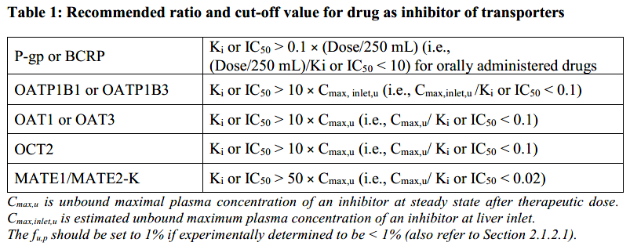  The recommended ratio and cut-off value for P-gp or BCRP is for orally administered drugs. If the investigational drug is administered parenterally or if it is a metabolite formed post-absorption that inhibits P-gp or BCRP, K_{i} or IC₅₀ > 50 × C_{max,u} (i.e., C_{max,u}/ K_{i} or IC₅₀ < 0.02) can be used.  The cut-off values in Table 1 were determined based on in vitro-to-in vivo extrapolation analyses. Since the majority of the in vitro inhibitory potency data in those analyses were IC₅₀, both IC₅₀ and K_{i} values can be used when applying the basic methods above. However, if the potential for an interaction is studied further with modeling approaches, Ki should be determined and used. It is recommended to use substrate concentrations less than K_{m} for in vitro transporter inhibition experiments. Assuming competitive inhibition, the K_{i} of an inhibitor approaches IC₅₀ when substrate concentration is much less than K_{m}.  The cut-off values described above are based on limited published data. Other cut-off values can be proposed if justified based on in vitro to in vivo extrapolation and a calibration of the specific in vitro systems with known inhibitors and non-inhibitors of these transporter systems.  If the above analysis indicates that a drug inhibits a transporter, a clinical study should be considered based on whether the likely concomitant medications used in the indicated patient populations are known substrates of the inhibited transporter and the safety profiles of those substrates. Alternatively, the inhibition potential of a drug can be evaluated using mechanistic static models, PBPK modeling, or endogenous biomarkers. These approaches should be supported by submission of evidence supporting validity of the methods.  2.2.3 Drug as an Inducer of Transporters  Currently, in vitro methods to evaluate transporter induction are not well established. If an investigational drug has been observed to be an inducer of CYP enzymes via activation of nuclear receptors such as PXR or CAR, it is likely that transporters regulated through these receptors will be induced, such as P-gp. Refer to Section 3.2.5 which describes conducting clinical DDI studies mediated by transporters for more considerations.
 | 2.3 DDI Potential of Metabolites | The assessment of DDI liability of an investigational drug’s metabolites often starts with in vitro experiments and generally uses the same strategies as those for parent drugs. As described below, evaluation of the DDI potential of metabolites with significant plasma exposure or pharmacological activities should be considered.  2.3.1 Metabolite as a Substrate  The risk of DDIs through altered formation or elimination of a metabolite should be investigated if available data indicate that change in metabolite exposure can result in clinically meaningful alteration of efficacy or safety of a drug (“target” as well as “off-target” effects). The enzymes responsible for formation and elimination of a metabolite should be identified in vitro if the metabolite contributes to an in vivo target effect to a similar or greater extent than the parent drug. The contribution to efficacy should be estimated by taking into account unbound metabolite and parent drug exposures (e.g., AUC expressed in molar units) in humans, pharmacological potency (e.g., receptor binding affinity, enzyme inhibitory potency), and if available, data related to target tissue distribution. If the plasma protein binding of the parent drug and the metabolite is high, it is preferred to determine their protein binding in the same study to reduce inter-study variability. In addition, if a metabolite is suspected to cause significant adverse effects based on available nonclinical or clinical information, major enzymes involved in the formation and elimination of that metabolite should be identified if possible. Similar to metabolic phenotyping for parent drugs, the characterization of enzymes involved in metabolite formation and metabolism should also start with major CYP enzymes and can examine other enzymes when appropriate.  The general principles described above can also be applied to characterization of a metabolite as a substrate of major transporters, with consideration of the relevance of transporter-mediated distribution or elimination in the disposition of a metabolite.  Whether a sponsor should conduct a clinical DDI study with an inhibitor or inducer of an enzyme or a transporter depends on the estimated fraction of formation or elimination of a metabolite mediated by an enzyme or transporter, how much the metabolite contributes to the clinical effect, the exposure-response relationship of the metabolite if known, and likely concomitant medications that affect the enzyme or transporter.  2.3.2 Metabolite as an Inhibitor  If in vitro assessments suggest that the parent drug inhibits major CYP enzymes and transporters and clinical DDI studies are planned, in vitro assessments of metabolites as enzyme or transporter inhibitors may not be needed because the inhibition potential of metabolites would be implicitly reflected in a clinical DDI study along with the parent drug, unless clinically relevant exposures of the metabolite cannot be adequately represented in the clinical DDI study (i.e., the study duration does not allow the metabolite to accumulate). It is noted that in vitro assessments of metabolites can become useful in interpreting the results of DDI studies.  If in vitro assessments suggest that the parent drug alone does not inhibit major CYP enzymes/transporters or is not expected to inhibit enzymes/transporters clinically, DDI liability due to metabolites as inhibitors can still exist. As a pragmatic rule, it is recommended to investigate the CYP enzyme and transporter inhibitory potential of metabolites that have AUC_{metabolite} ≥ 25% of AUC_{parent} and also account for at least 10% of drug-related material in circulation (i.e., considered as major metabolite often determined based on radioactivity data).  Based on the results of in vitro DDI assessments of a metabolite, the determination of whether to conduct a clinical DDI study follows the same approaches as those for the parent drug, except that some metabolites could be irrelevant for the evaluation of intestinal CYP or transporter inhibition. If basic methods suggest that the metabolite(s) could have in vivo DDI liability, and a mechanistic static or PBPK model is then used to evaluate the DDI risk of a drug, metabolite(s) should be incorporated in those models.  2.3.3 Metabolite as an Inducer  While metabolites can induce CYP enzymes, the in vitro evaluation of the parent drug as a potential inducer could also reflect induction by metabolites because metabolites can be generated during incubation of the parent drug with hepatocytes. However, when the drug is a prodrug or a metabolite is mainly formed extra-hepatically, in vitro evaluation of a metabolite’s induction potential on CYP enzymes is recommended if the metabolite is a major metabolite and has AUC_{metabolite}/AUC_{parent} ≥ 25%. Based on the results of in vitro assessments of the metabolite, the determination of whether to conduct a clinical DDI study follows the same approach as for the parent drug.
3. CLINICAL EVALUATION
 | 3.1 Types of Clinical DDI Studies (Terminology) | There are different study types that can be conducted to determine the presence or absence of a clinical DDI and the magnitude of the DDI if one exists. The study types described in this section are not mutually exclusive. The specific goal of a study should be considered when determining the type of study to conduct.  Regulatory decision-making generally relies upon prospective studies specifically designed to evaluate the potential for DDIs. Retrospective evaluation of drug concentrations from studies not designed to evaluate DDIs rarely includes sufficient accuracy and precision to provide an adequate assessment. DDIs identified or ruled out using a retrospective analysis may need to be confirmed using a prospective evaluation.  In some situations, predictive modeling approaches (mechanistic static or PBPK) can be used to translate in vitro results to the clinical setting, without a clinical DDI study. The scenarios and best practice considerations are described in Section 7.3.  3.1.1 Standalone and Nested DDI Studies  A stand-alone DDI study is a clinical study with the primary objective of determining the presence or absence of a clinical DDI and the magnitude of the DDI. Alternatively, DDIs can be evaluated as part of larger studies in patients (e.g., phase 2/3) for which DDI evaluation is not the primary objective, if the DDI evaluation is prospectively planned and appropriately designed. As such, the DDI evaluation is nested within a larger study (refer to Section 3.2.2 for more details).  3.1.2 DDI Studies with Index Perpetrators and Index Substrates  Perpetrators (inhibitors or inducers) and substrates (victims) with well-understood and predictable pharmacokinetic and DDI properties with regard to level of inhibition, induction, or metabolic pathway are known as “index drugs”. The most common purpose of studies conducted with these drugs is to estimate the greatest magnitude of interaction for the studied pathway. For drugs that are evaluated as victims of a DDI, the greatest magnitude of interaction generally results from concomitant administration of a strong index inhibitor or inducer of the drug's metabolic pathway(s). For drugs evaluated as perpetrators of DDIs, the greatest magnitude of interaction generally results from concomitant administration of the drug with a sensitive index substrate.  A distinctive feature of index studies is that the results usually can be extrapolated to other drug combinations. Thus, after conducting a study with an index inhibitor, one can assume that other inhibitors of equal strength for that metabolic pathway will generally have a similar DDI effect size. Additionally, if one concludes that the change in drug exposure following a concomitant strong index inhibitor is not clinically relevant, the same can be concluded for all other inhibitors for that particular metabolic pathway without additional studies. Results from DDI studies with index perpetrators or substrates are also used to help design DDI studies with commonly used concomitant medications in the investigational drug’s target population.  A list of index drugs (either as substrates, inhibitors, or inducers) is presented in Section 7.5.1.  Index substrates or perpetrators have not been identified for transporters and several metabolic pathways (e.g., CYP2B6, UGTs). The lack of index substrates or perpetrators is mainly due to selectivity issues. However, information similar to that provided by studies with index perpetrators or substrates (i.e., the likelihood of a DDI due to a specific pathway) is often important. Although index substrates and perpetrators have not been identified, Sections 7.5.2 and 7.5.3 list drugs that can be useful for DDI studies because they provide informative results and explain the limitations of the drugs. However, extrapolation of results of these studies can be more difficult than extrapolation of results from studies with index drugs.  3.1.3 DDI Studies with Expected Concomitant Drugs  It can be informative to conduct studies that investigate DDIs between the investigated drug and drugs likely to be administered to the target population. These studies can also be considered when a drug is used as an add-on to other therapies or as part of a fixed dose combination. When choosing drugs to evaluate in these studies, sponsors should consider the mechanistic understanding of the potential for DDIs and the relative frequency of co-administration. Results of studies with index drugs can help determine what additional studies should be conducted.  Because of a general lack of index substrates or perpetrators for transporter-mediated pathways and several metabolic pathways (UGTs; CYP2B6), the choice of transporter substrates or perpetrators for DDI evaluation is often based on the likelihood of co-administration.  Although these studies are often informative to patients and medical professionals, the results could be difficult to extrapolate to other drugs.  3.1.4 Cocktail Approach  A cocktail study includes the simultaneous administration of substrates of multiple enzymes and/or transporters to study subjects. A cocktail approach can simultaneously evaluate a drug’s inhibition or induction potential for multiple enzymes and transporters if the study is properly designed and conducted (refer to Section 3.2.6 for additional details).
 | 3.2 Study Planning and Considerations for Clinical DDI Studies | The objective of most DDI studies is to determine the ratio of a measure of substrate drug exposure (e.g., AUC ratio) in the presence and absence of a perpetrator drug. The following considerations are important when designing prospective clinical DDI studies to unambiguously determine this ratio.  3.2.1 Study Design  3.2.1.1 Study Population and Number of Subjects  Most clinical DDI studies can be conducted using healthy subjects, under the assumption that findings in healthy subjects translate to findings in the intended patient population. However, safety considerations can prevent the use of healthy subjects in studies of certain drugs. For some drugs, use of the intended patient population in DDI studies can allow for evaluation of pharmacodynamic endpoints that cannot be studied in healthy subjects, in addition to PK endpoints.  The number of subjects included in a DDI study should be sufficient to provide a reliable estimate of the magnitude and variability of the interaction.  3.2.1.2 Dose  For studies intended to identify the interaction of greatest magnitude, the doses of the perpetrator drug used in DDI studies should maximize the possibility of identifying a DDI. Thus, the maximum dose and the shortest dosing interval of the perpetrator under the intended conditions of use should generally be evaluated.  If the victim drug has dose-proportional pharmacokinetics, sponsors can study any dose in the range where exposure to the drug increases in a dose-proportional manner. If the victim drug has dose-dependent pharmacokinetics, the therapeutic dose most likely to demonstrate a DDI should be used. When there are safety concerns, lower doses of the victim drug can be used.  For studies with anticipated concomitant drugs when a clinically significant DDI is anticipated, it can be informative to build a dose adjustment of the victim drug into the study to allow identification of doses that can be administered together in clinical practice. In such a scenario, a clinically relevant dose of the perpetrator should be used.  3.2.1.3 Single or Multiple Doses  The perpetrator drug is often administered in a multiple dose regimen in DDI studies. However, sponsors can evaluate single-dose administration of a perpetrator if the interaction potential is only relevant during absorption (e.g., inhibition of intestinal P-gp or BCRP).  In addition, DDI studies can evaluate single-dose administration of a perpetrator if the exposure of perpetrator following a single dose is representative of exposure at steady-state and if the perpetrator is not a potential inducer or time-dependent inhibitor. When studied with a substrate with a long half-life, it may be necessary to administer a perpetrator multiple times to cover the full time-course of the substrate exposure. The duration of the treatment with the perpetrator should be long enough to cover at least 90% of the plasma concentration-time curve of the victim. However, if the victim has a very long terminal half-life that does not allow dosing with the perpetrator to cover the full AUC, population PK analysis or PBPK analysis can be used to estimate the full interaction effect on the exposure of the victim.  If a metabolite of the perpetrator has demonstrated time-dependent inhibition of the enzyme being evaluated in the DDI study, the duration of the treatment with the parent drug should be sufficient for steady state of the metabolite to be reached.  Inducers should be administered as multiple doses to ensure the maximal induction of a specific pathway. It may take about 2 weeks of daily drug administration to achieve the maximum level of induction in a specific pathway. Shorter treatment duration of perpetrators can be used with appropriate justification. When there are multiple mechanisms of interactions for a specific perpetrator, single-dose administration can be appropriate in certain situations (e.g., evaluation of rifampin as an inhibitor of OATP1B1), while multiple-dose administration can be appropriate in other situations (e.g., evaluation of rifampin as a CYP3A inducer).  If the substrate does not demonstrate time-dependent pharmacokinetics, the substrate can be administered as single doses, and the observed magnitude increase in exposure can be extrapolated to steady-state conditions. If the substrate demonstrates time-dependent pharmacokinetics, multiple-dose administration of the substrate and a perpetrator should be evaluated.  3.2.1.4 Formulations and Route of Administration  The route of administration of the investigational drug evaluated in DDI studies should generally be the one planned for routine clinical use. When multiple routes of administration are developed for clinical use, the route of drug administration for DDI studies should be selected based on the expected mechanisms of the DDIs and the similarity of the concentration-time profiles for the parent drug and metabolites after different routes of administration.  Formulation-related differences in DDIs may also occur. There are several examples of excipients resulting in altered DDIs (25, 26). The possibility of formulation differences in interaction potential should be considered when extrapolating interaction results between formulations (27, 28). In general, DDI potential can be extrapolated between formulations by comparing their rate and extent of absorption.  3.2.1.5 Parallel Versus Crossover Studies  Crossover studies (one-sequence or randomized) are preferred over parallel study designs in order to reduce variability. Duration of the washout period should be based on the pharmacokinetics of the substrate and the perpetrator, the anticipated impact on the substrate’s half-life, and the duration necessary for enzyme activity to return to baseline or for potential pharmacodynamic effects to return to pre-treatment levels (if pharmacodynamic effects are also assessed). In some situations, additional crossover periods can be informative (e.g., to evaluate the time it takes for enzyme activity to return to normal following removal of an inducer or time-dependent inhibitor, to evaluate two drugs that may affect each other (each drug alone and in combination), or to evaluate the effects of acute and chronic treatment of a drug).  Parallel, two-arm studies can be appropriate when a crossover study design is not feasible, such as when one of the drugs has a long half-life. Typically, parallel-design studies call for larger sample sizes than crossover studies and subjects should be matched for intrinsic factors likely to affect pharmacokinetics.  3.2.1.6 Timing of Drug Administration  In most DDI studies, the perpetrator and victim drugs can be administered at the same time. However, the timing of administration of the perpetrator is critical if it is both an inhibitor and an inducer. For example, rifampin is an inducer of multiple enzymes and transporters, and also an inhibitor of transporters (e.g., OATP1B and P-gp). If rifampin, after a pre-treatment period, is co-administered with a drug that is a substrate of an inducible enzyme and also OATP1B1 and/or P-gp, the observed exposure change of the victim reflects the net effect and underestimates the effects of other inducers that do not inhibit OATP1B1 and/or P-gp. To determine the impact of induction, staggered administration of rifampin with the victim (e.g., separated by 24 hours) is recommended.  If a large part of an interaction occurs during absorption or first pass, staggered dosing schedules can be studied (clinical study or PBPK) to understand whether such a method is a viable mitigation strategy for the DDI.  When evaluating the interaction between drugs that require different food conditions for optimal absorption, the timing of drug administration should be adjusted to maximize the potential to detect an interaction (i.e., index studies) and/or to reflect the clinically relevant conditions (i.e., concomitant use studies).  3.2.1.7 Co-Medications and Other Extrinsic Factors Affecting DDIs  To reduce variability in the magnitude of DDIs, use of the following should be excluded to the extent possible during DDI studies: other medications, dietary/nutritional supplements, tobacco, alcohol, foods, and fruit juices that may affect the expression or function of enzymes and transporters. The exclusion should begin for a sufficient time before subjects enter the study and continue for the duration of the study.  3.2.1.8 Sample and Data Collection  PK sampling times should be sufficient to characterize the AUC_{0-inf} (for single-dose studies) or the AUC_{0-tau} (for multiple-dose studies) and C_{max} of the substrate drug administered alone and under conditions of the anticipated interaction. Data on additional pharmacokinetic parameters should be collected based on the pharmacokinetic or pharmacological relevance for the proposed indication (e.g., the minimum concentration (C_{min}), partial AUC). The sampling times for single-dose studies should be planned so that the mean difference between the AUC_{0-t} and the AUC_{0-inf} is less than 20 percent. Samples collected should contain the moieties needed to interpret study results; in most cases, the moiety needed to interpret results will be the parent drug. Metabolite concentrations should be determined if they provide information about the effect of a DDI on safety or efficacy, or if the data inform the mechanism of the drug interaction.  3.2.1.9 Pharmacodynamic Endpoints  When in vitro data provide a plausible DDI mechanism that cannot be evaluated with systemic drug exposure, collection and analysis of pharmacodynamic data can be informative. One possible scenario where this could occur is when transporter inhibition alters access of the drug to specific organs or tissues. In such scenarios, clinical consequences, such as altered efficacy or increased toxicity resulting from altered tissue distribution of a substrate drug, can be measured as pharmacodynamic endpoints, and in vitro evidence of a drug’s interaction potential can support data interpretation.  3.2.2 Specific Considerations for Nested DDI Studies  Nested DDI studies are clinical DDI investigations that are part of other studies (e.g., phase 2/3) in which the assessment of DDI is not the primary objective. However, these trials are designed prospectively to investigate DDIs as an exploratory or secondary objective. Nested DDI studies are usually used to evaluate the drug as a victim of concomitant drugs and sometimes can also be used to assess the drug as a perpetrator. The results of such analyses can be informative, and sometimes conclusive, when the clinical studies are adequately designed to detect significant changes in drug exposure due to DDIs. An advantage of nested DDI studies is the fact that they are conducted in a patient population and may more closely represent the anticipated clinical setting. However, nested DDI studies can also be challenging because they call for careful attention to study design and data collection. In some cases, PBPK modeling can assist the design of nested DDI studies (refer to Section 7.3.2). If large interactions are anticipated that would result in clinically unacceptable risks to subjects, including increased toxicity or decreased efficacy, sponsors should consider whether another approach to DDI evaluation is more appropriate (29).  A nested DDI study can evaluate the effect of concomitant drugs that are used for the full duration of the clinical trial or those that are added in response to the patient’s condition during the trial. Concomitant drugs to be evaluated should be prespecified. The drugs are typically selected because there is a mechanistic reason to anticipate an interaction. Relevance in the patient population is also a consideration. The study design can specify individual drugs or a grouping, based on mechanism (e.g., strong CYP3A inhibitors) (30). However, if a grouping is evaluated it is important to consider the potential for differences in the effect of different drugs in the group and the effect of the potential variability on data analysis and translation of the findings.  Simulations can be used to determine the appropriate number of PK samples and to assist in the selection of sampling times. A power analysis can also be performed to estimate the minimum effect size that is likely to be detected with acceptable precision in a study using a given number of patients on a concomitant drug.  Collection of the following data is critical to ensure interpretable results: timing of drug administration (investigational drug and concomitant drug), drug dose, timing relative to food (when relevant), other concomitant drugs, and PK sampling date and time (actual, not scheduled). It is also important to document the start date of the concomitant drug relative to when an interaction will be observed, particularly when the concomitant drug is an inducer or time-dependent inhibitor.  Nested DDI studies are typically evaluated using population PK analysis, which should be performed according to well-established scientific practice using a model that is validated in relation to its purposes. The population PK analysis plan for the DDI assessment should be established prior to conduct of the study. In general, the standard analysis approach is a binary evaluation that includes the concomitant drug as a static categorical covariate. Sponsors should consider whether their selected analysis methods will provide the desired level of precision in DDI evaluation. Regardless of analysis method, all assumptions should be stated.  In some instances, unplanned analyses of potential DDIs in phase 2/3 trials are conducted to explain clinical study results, such as safety or efficacy issues in a group of patients, or to screen for potential DDIs not anticipated at the time the trials were designed. If the data collected meet the criteria described above, it can be possible to draw conclusions about the presence or absence of an interaction. In situations where the data do not permit an accurate assessment of a DDI, a confirmatory evaluation of the DDI should be conducted.  3.2.3 Considerations for CYP-Mediated Interactions  3.2.3.1 The Investigational Drug as a Substrate for CYP Enzymes  When evaluating the investigational drug as a substrate, the first clinical DDI studies should, in general, determine the effects of a strong index inhibitor and a strong index inducer on the investigational drug. Moderate index inhibitors or inducers can be used if strong index inhibitors or inducers are not available for a particular enzyme. Some of these inhibitors and inducers can also affect other metabolism and/or transporter pathways; thus, when selecting index inhibitors and inducers for prospective DDI studies, all metabolic and transport pathways of the investigational drug should be considered. Studies with other strong inhibitors and inducers of CYP enzymes can also be appropriate, considering the criteria listed in Section 7.5.1. If the investigational drug is a substrate for multiple enzymes and/or transporters, measuring metabolites can, in some cases, help with the interpretation of study results and interacting mechanisms.  If a DDI study with a strong index inhibitor or inducer indicates no DDI is present, additional clinical studies with other inhibitors or inducers of the same enzyme are not needed. However, as a negative DDI study may reveal that the enzyme proposed to be the major metabolizing enzyme based on in vitro data is not contributing to the elimination of the drug, this may instead indicate that further clinical investigations with strong inhibitors of alternative candidate enzymes should be conducted.  If a DDI study with strong index inhibitors or inducers indicates that there is a clinically relevant interaction, evaluating the impact of moderate inhibitors or inducers can be useful to gain a full understanding of the investigational drug’s DDI potential. The evaluated moderate inhibitors and inducers may be anticipated concomitant medications in the intended patient population. The effect of the additional inhibitors and inducers can be evaluated in a clinical interaction study, or, in some cases, modeling approaches can provide additional information (refer to Section 7.3). If it is anticipated that co-administration with strong inducers or inhibitors should be avoided, a DDI study with a moderate inducer or inhibitor may be preferable as the initial study.  If the investigational drug is subject to significant metabolism by a genetically polymorphic enzyme for which a well-defined poor metabolizer phenotype exists that results in non-functional enzyme activity, a comparison of the pharmacokinetic parameters of the drug in individuals with the poor metabolizer phenotype versus those with a normal metabolizer phenotype can substitute for an interaction study for that particular pathway (refer to Section 4.1).  3.2.3.2 The Investigational Drug as an Inhibitor or an Inducer of CYP Enzymes  When studying an investigational drug as a potential inhibitor or inducer of a CYP enzyme, the index substrate selected for the initial clinical studies should be sensitive to changes in activity or amount of the CYP enzyme being evaluated (refer to Section 7.5.1). Because some substrates are not specific for one CYP enzyme and sometimes are also substrates of transporters, the most appropriate substrate should be selected considering the inhibitor/inducer characteristics of the investigational drug, based on available in vitro and clinical data. Other CYP enzyme substrates can also be appropriate. If the substrate drug is metabolized by more than one enzyme, measuring metabolites sometimes can help with interpretation of study results.  If the initial study with the most sensitive index substrates is negative, studies with less sensitive substrates of the enzyme are not needed. If an initial study determines that an investigational drug either inhibits or induces the metabolism of sensitive index substrates, further studies using other substrates (e.g., relevant co-medications) can be useful. The magnitude of the effect of the investigational drug on the sensitive index substrate and the potential for concomitant use with other drugs that are substrates of the same enzyme should be considered.  If the investigational drug is both an inducer and an inhibitor of an enzyme, the net effect of the drug on enzyme function may be time dependent. The timing of pharmacokinetic endpoints should permit an understanding of the changes in effects over time, when relevant (31). To achieve this understanding, the pharmacokinetics of the victim drug should be evaluated at early and late time points during the administration of the investigational drug in the test period. The effect of reversible inhibition may be more pronounced in the beginning of the treatment and the induction may be most pronounced after ending the treatment.  3.2.4 Considerations for Evaluation of UGT-Mediated Interactions  3.2.4.1 Investigational Drug as a Substrate of UGTs  Based on limited literature evidence, the magnitude of DDI mediated through inhibition of UGTs (reflected by AUC ratio of a substrate in the presence of an inhibitor compared to no inhibitor) rarely exceeds 3-fold and is often around 2-fold or less (32). For an investigational drug that is mainly eliminated by direct glucuronidation, clinical DDI studies with UGT inhibitors should be conducted on a case-by-case basis, considering the safety profile of the drug and the likelihood of its concomitant use with inhibitors of that UGT isoform (refer to Table 16, Section 7.5.2 for some examples of UGT inhibitors). Some UGT substrates are also substrates of other enzymes or transporters, and the interaction with a UGT inhibitor may involve other mechanisms when the UGT inhibitor also affects those enzymes or transporters. Thus, it may be valuable to also measure the glucuronide conjugate concentrations in addition to the UGT substrate itself. The change of glucuronide metabolite relative to the parent drug may provide insight into the underlying mechanism of interaction. In addition, some glucuronide metabolites are active or reactive and may significantly contribute to efficacy or safety of a drug. In such cases, the concentrations of glucuronide conjugates should be measured in addition to parent drug concentrations.  Genetic variation in certain UGT enzymes (for example, UGT1A1, UGT2B7, and UGT2B15) has been reported to contribute to variation in the pharmacokinetics of drugs metabolized by UGTs. In certain cases, comparative PK data in subjects with various UGT genotypes can be used to identify the importance of the UGT pathway(s) in the elimination of a drug in vivo and to estimate the extent of DDI with inhibitors of UGT.  In addition, UGTs can also be induced, for example, by certain PXR agonists (e.g., moderate or strong CYP3A inducers). The impact of inducers on an investigational drug that is mainly metabolized by UGTs should also be considered and evaluated depending on the likelihood of its concomitant use with UGT inducers and the dose/exposure-efficacy relationship of the investigational drug.  3.2.4.2 Investigational Drug as an Inhibitor of UGTs  Due to the limited availability of data from clinical DDI studies that evaluate inhibition of UGT isoenzymes, cutoffs for determining DDI risk using basic models like those for CYP enzymes have not been established. This is an area of ongoing research, and in the interim, sponsors can consider the same criterion as the one applied to CYPs (i.e., compare C_{max,u}/K_{i,u} < 0.02), or propose an alternative with justification. A decision on whether to perform a clinical DDI study to evaluate the effect of a drug as a UGT inhibitor should also take into consideration the likelihood of the drug’s concomitant use with known substrates of the UGT isoform (refer to Table 15, Section 7.5.2 for examples) and the safety profiles of those substrates.  3.2.4.3 Investigational Drug as an Inducer of UGTs  There is limited understanding about gene expression of UGTs. However, limited clinical DDI studies indicate certain UGTs may be induced by agonists of PXR and/or CAR, which also regulate CYP3A4 expression. UGTs are less inducible than CYP3A4. Thus, for a drug found to induce CYP3A4 in vitro and further evaluated with a clinical DDI study, the effect of the drug on CYP3A4 substrates may inform its potential induction effect on UGTs. If a drug reduces the AUC of a sensitive substrate of CYP3A by ≥50%, a further clinical DDI study can be conducted with the drug and a UGT substrate, depending on the magnitude of exposure change of the CYP3A substrate, the likelihood of concomitant use of the investigational drug with UGT substrates, whether there are other enzymes/transporters involved in the pharmacokinetics of UGT substrates which can also be regulated by PXR/CAR agonists, and the dose or exposure-efficacy relationship of those UGT substrates. It is noted that some CYP3A4 inducers have their induction effect overridden by their inhibition effect on CYP3A. Thus, while those drugs inhibit CYP3A4 in clinical studies, they may exhibit induction effects on UGTs.  3.2.5 Considerations for Evaluation of Transporter-Mediated Interactions  3.2.5.1 Investigational Drug as a Substrate of Transporters  If in vitro studies indicate that the investigational drug is a transporter substrate, sponsors should determine whether to conduct clinical DDI studies based on the drug’s passive permeability, route of administration, in vivo absorption and elimination, putative site of action, safety profile, dose or exposure-response (efficacy and safety) relationship, and likely concomitant drugs that are known inhibitors or inducers of the transporters. The following general guidelines in Table 2 help to determine when a clinical DDI study is generally recommended for investigational drugs that are transporter substrates in vitro:  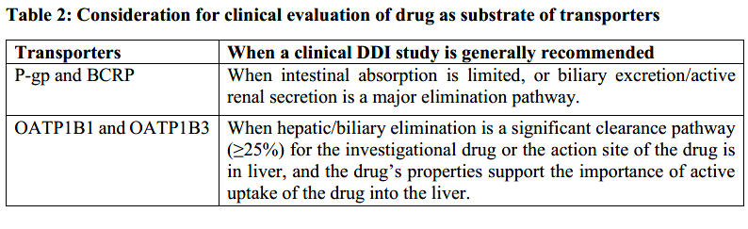  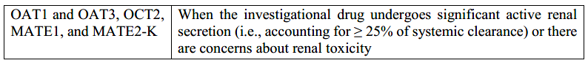  When evaluating an investigational drug as a victim in transporter-mediated DDIs, the selected perpetrator drug should be a known inhibitor of the transporter under investigation. Because of a general lack of index perpetrators for transporter-mediated pathways, the choice of transporter perpetrator is typically based on the likelihood of concomitant use (e.g., to obtain clinically relevant DDI information that can inform labeling regarding the management of a DDI).  Transporter inhibitors can be used to understand the underlying mechanisms of DDIs or to determine the anticipated largest magnitude DDI. If in vitro studies indicate a drug is a substrate of multiple transporters, a clinical study can be conducted with a broad inhibitor of multiple transporters to determine the anticipated largest magnitude DDI. For example, cyclosporine, which inhibits intestinal P-gp and BCRP and hepatic OATPs, can be used as the inhibitor in a DDI study. Negative results from this kind of study may rule out the need to further evaluate the drug as a substrate for any of the individual transporters. If the study result is positive, additional studies with more selective inhibitors of specific transporter pathways can be conducted to determine the impact of inhibition of each transporter on the disposition of the substrate drug. The same paradigm can apply to an investigational drug that is a substrate for both transporters and metabolic enzymes (e.g., CYP3A and P-gp).  If the goal of the study is to determine the role of a specific pathway in the pharmacokinetics of a substrate drug and resulting DDIs due to that pathway, then a more selective inhibitor should be used. Use of these inhibitors in clinical studies can provide a mechanistic understanding of transporter-mediated DDIs. Some transporters, including OATP1B1 and BCRP, are encoded by genetically polymorphic genes (SLCO1B1 and ABCG2, respectively) for which phenotypes with reduced functionality exist. Similar to drugs that are substrates of CYPs encoded by polymorphic genes, the relative contribution of a specific transporter to the disposition of the investigational drug can be evaluated in subjects with different transporter genotypes (refer to Section 4.1).  Examples of transporter inhibitors are listed in Section 7.5.3.2. Many of them not only inhibit the specified transporters but also can inhibit other transporters and/or CYP enzymes. Thus, extrapolation of results from transporter inhibition studies to other drugs can be challenging. Interpretation of the study results should consider the knowledge of transport and metabolic pathways for the investigational drug.  3.2.5.2 Investigational Drug as an Inhibitor of Transporters  If in vitro studies indicate that the investigational drug is a transporter inhibitor, the determination of whether to conduct a clinical DDI study should be based on likely concomitant drugs and safety considerations. When studying the investigational drug’s potential to act as an inhibitor drug for a transporter, a substrate drug whose pharmacokinetic profile is markedly altered by coadministration of known inhibitors of that transporter and is also a likely concomitant drug is preferred. Some examples of transporter substrates that can be used in DDI studies are listed in Section 7.5.3.1. Because many drugs are substrates of multiple transporters and/or enzymes, the observed clinical interactions can be a result of the modulation of multiple pathways if the investigational drug is also an inhibitor or inducer for those pathways. Extrapolation of results from these studies to other drugs can thus be challenging. The choice of substrates can be determined by the therapeutic area of the investigational drug and the likely concomitant drugs that are known substrates of the transporters.  In some cases, an alteration in drug transport may not be fully reflected by changes in plasma concentrations alone. Therefore, measurement of metabolite or pharmacodynamic markers to reflect altered distribution to the organs expressing the transporter should be included to interpret the potential for an interaction.  Recent literature reports indicate potential utility of endogenous substrates for some drug transporters (33-37). Evaluating the change in exposure of the endogenous substrate when the investigational drug is administered may provide information regarding the drug’s potential as a transporter inhibitor.  3.2.5.3 Investigational Drug as an Inducer of Transporters  Since P-gp is co-regulated with CYP3A, for example by agonists of PXR and/or CAR, but is less inducible than CYP3A (38, 39), if an investigational drug reduces the AUC of a sensitive substrate of CYP3A by 50% or more (i.e., being a moderate or strong inducer), a further clinical study to evaluate potential induction effect of the drug on P-gp substrates should be considered, taking into account the following factors: the magnitude of CYP3A substrate AUC change by the investigational drug, the likelihood of concomitant use of the drug with P-gp substrates, whether there are other enzymes/transporters involved in the pharmacokinetics of P-gp substrates which can also be regulated by PXR and/or CAR agonists, and the dose or exposure-efficacy relationship of P-gp substrates. It is noted that some CYP3A4 inducers have their induction effect overridden by their inhibition effect on CYP3A. Thus, while those drugs inhibit CYP3A4 in clinical studies, they may exhibit induction effects on P-gp. Sponsors should also consider whether to conduct clinical DDI studies to evaluate the potential effect of a drug on other transporters regulated through the same pathways as CYP3A.  3.2.6 Cocktail Studies-Considerations for CYP or Transporter Cocktail Studies  A cocktail approach can simultaneously evaluate a drug’s inhibition or induction potential for multiple CYPs and transporters if the study is properly designed. Ideal conditions for the cocktail study are: (1) the substrates are specific for individual CYP enzymes or transporters; (2) there are no interactions among the substrates; and (3) the study is conducted with a sufficient number of subjects. If the first two conditions are not met, the lack of specificity or the interaction among substrates should be understood and incorporated into the study results interpretation. Negative results from a well-conducted cocktail study can eliminate the need for further evaluation of particular CYP enzymes or transporters. Positive results from a well-conducted cocktail study that includes all elements of a prospective DDI study can be interpreted the same way as positive results from any other well-conducted DDI study. It should be noted that findings obtained with a microdose of a substrate cannot always be extrapolated to a therapeutic dose of that substrate.
4. OTHER TOPICS
 | 4.1 Pharmacogenetics | Pharmacogenetic variations in genes encoding drug metabolizing enzymes or drug transporters can affect the pharmacokinetics of a drug, increase interindividual variability in drug exposure, affect safety or efficacy, and alter the magnitude of DDIs. Important pharmacogenes include those that encode phase 1 (e.g., CYP2C9, CYP2C19, CYP2D6) and phase 2 (e.g., NAT2, UGT1A1) drug metabolizing enzymes as well as genes that encode drug transporters (e.g., BCRP, OATP1B1). Polymorphisms in metabolizing enzymes can lead to increased, normal, decreased, or absent enzyme activity resulting in ultra-rapid (UM), normal or extensive (NM or EM, hereafter referred to as NM), intermediate (IM), and poor (PM) metabolizers, respectively. Polymorphisms in drug transporters can increase or decrease transport of a drug across membranes. These drug metabolizing enzyme and transporter polymorphisms can affect the systemic or tissue concentrations of a drug and/or its metabolite(s).  The scope of this section is limited to the evaluation of the impact of pharmacogenetics on DDIs and on DDI evaluation. While the considerations described below use metabolizing enzymes as examples, the concept can also be applicable to transporters with polymorphisms.  If an investigational drug is a substrate/inhibitor for a polymorphic enzyme and a DDI study with an index inhibitor/substrate is conducted to evaluate pharmacokinetic changes, it is recommended to prospectively characterize the subject’s genotype. Exclusion of PMs is recommended, to allow characterization of the greatest magnitude of interaction. If PMs are not excluded, the DDI effect should be evaluated separately in subjects with different phenotypes (e.g., PM, IM, and NM), as relevant.  If an investigational drug is subject to significant metabolism by an enzyme with a well-defined PM phenotype (for example, CYP2D6, CYP2C19), exposure in PM is expected to be similar to the effect of a strong inhibitor of that pathway. A comparison of the pharmacokinetic parameters of the drug in individuals with the PM phenotype with those with a NM phenotype can substitute for a DDI study of that pathway with a strong inhibitor. Similarly, the exposures in subjects with a polymorphic PM phenotype could be estimated using the results of an in vivo DDI study with a strong inhibitor. If there is a significant difference in exposure between individuals with the PM and NM phenotypes, further studies to evaluate the DDI potential with moderate inhibitors or inducers of the specific enzyme should be considered.  When an enzyme encoded by a polymorphic gene is one of two major elimination routes of an investigational drug, the interaction effects of inhibiting the other enzymes is expected to vary in different phenotypes of the polymorphic enzyme. In a DDI study evaluating the impact of inhibitors of the other enzyme, prospective genotyping and enrichment of subjects with absent or decreased function of the polymorphic gene besides NM subjects can help assess the interaction effects in the various phenotypes. Because the DDI magnitude may become large in PMs or IMs of the polymorphic enzyme when combined with an inhibitor of a parallel pathway, depending on the safety profile of the drug, different doses should be considered in those subjects. PBPK modeling can be useful to supplement such studies or to extrapolate the interaction effects in different genotypes (refer to Section 7.3.2).  A retrospective pharmacogenetic analysis can help elucidate reasons for a high variability in a DDI study. When study enrollment is not based on the genotype of a polymorphic metabolizing enzyme or transporter, a retrospective analysis of the metabolizing enzyme or transporter of interest can help to characterize differences in the magnitude of the DDI across genotype groups and explain why some subjects have unanticipated increases or decreases in drug concentrations.  Guidance on DNA sample collection for prospective and retrospective pharmacogenetic analysis can be found elsewhere (40, 41). As the frequency of certain pharmacogenetic variations can vary across populations, when performing pharmacogenetic analysis, an individual’s race/ethnicity should be considered. In addition, regional regulations on sampling and analyzing human derived materials need to be followed.
 | 4.2 Therapeutic Protein DDIs | In general, the risk of pharmacokinetic DDIs is lower for proteins. The in vitro assays that are applicable for small molecules are generally not applicable to proteins.  When evaluating the potential for a DDI between monoclonal antibodies and small molecules or between monoclonal antibodies, the mechanisms of a potential DDI should be considered, taking into account the pharmacology and clearance of the monoclonal antibodies as well as any co-administered medications in the patient population.  4.2.1 Proinflammatory Cytokine-Related Mechanism  Certain therapeutic proteins may exert an indirect effect on expression of CYP enzymes and thus affect the pharmacokinetics of small molecules. Therapeutic proteins that are proinflammatory cytokines (e.g., peginterferon) or that can increase cytokine levels can down-regulate the expression of CYP enzymes, thereby decreasing the metabolism of drugs that are CYP substrates and increasing their exposure levels. The increase in cytokine levels as a result of drug treatment can be transient or persistent; sponsors should consider this increase when determining whether to conduct a DDI study as well as the design of that study.  Conversely, therapeutic proteins that reduce the elevated cytokine levels (e.g., inhibitors of tumor necrosis factor) can relieve the CYP down-regulation from an inflammatory environment (e.g., rheumatoid arthritis), thereby increasing CYP expression and activity and reducing exposure for CYP substrates.  If the investigational drug is a cytokine or a cytokine modifier, sponsors should consider whether to perform a clinical DDI study to evaluate the effects of the investigational therapeutic protein on sensitive substrates for CYP enzymes. Known drug effects on metabolism in disease states with similar or higher inflammatory burden, differences in exposure levels of sensitive CYP substrates in healthy subjects versus patients in the indicated population, and the magnitude of the drug effect on cytokine levels should be considered when determining whether to conduct a clinical study. In some cases, a DDI study in the relevant indicated population should be conducted to further inform instructions for use of the drug. Important design aspects include the disease type and severity in the included patients and the dose and treatment time of the perpetrator drug.  4.2.2 Antibody-Drug Conjugates  For antibody-drug conjugates (ADCs), the small molecule drug component conjugated to the antibody component can be released in unconjugated form. Therefore, the DDI potential of both the antibody and the small molecule drug component should be considered. In general, for the small molecule component, the potential to inhibit or induce enzymes and transporters should be addressed in line with what is described elsewhere in this guideline. In many cases, however, the systemic concentration of free drug might be too low to act as a perpetrator in vivo.  It is important to understand the formation, distribution and elimination kinetics of the small molecule and to assess the systemic exposure of the small molecule drug component of the ADC. It might be necessary to evaluate the small molecule component (administered as an ADC) as a victim drug, in particular if increased levels of free drug may be associated with safety concerns. Understanding the exposure-response relationship of the various moieties is important in determining whether to conduct DDI studies and their significance.
5. REPORTING AND INTERPRETING CLINICAL DDI STUDY RESULTS |  | A DDI study report should include and justify the study design and data analysis method based on what is known about the mechanism of the DDI and the PK properties of the perpetrator and victim drugs. Data analysis of pharmacokinetic parameters (and pharmacodynamic parameters, when relevant) should include all subjects enrolled in the study who have evaluable PK and/or pharmacodynamic data. If a subject is dropped from the study or has incomplete plasma concentration sampling during a treatment period, the possibility that the observation is due to an interaction should be considered. When indicated, the interaction effect should be presented with and without the individuals proposed for exclusion.
 | 5.1 Pharmacokinetic Data Analysis | 5.1.1 Non-Compartmental Analysis (NCA)  The following exposure measures should be determined for each subject: AUC_{0-inf}, AUC_{0-t}, the percent extrapolated from AUC_{0-t} to AUC_{0-inf,} C_{max}, and time to C_{max} (T_{max}). For multiple-dose studies, C_{max}, C_{min}, AUC_{TAU} at steady-state should also be reported. Additional parameters can help to interpret the PK results: clearance, half-life, and volume of distribution. Parameters for metabolites, when measured, should also be presented. NCA can be used to evaluate DDI studies conducted to evaluate the investigational drug as a victim or perpetrator.  5.1.2 Population PK Analysis  PK data collected in nested DDI studies should typically be evaluated using population PK methods. DDIs should be evaluated using all plausible structural elements of the PK model (e.g., clearance (CL or CL/F), relative bioavailability, rate of absorption). Population PK analyses should derive PK parameters appropriate for the study design and PK properties of the drug, such as AUC and C_{max}. For multiple-dose studies, C_{max}, C_{min} and AUC_{0-TAU} at steady-state should be reported.
 | 5.2 Reporting DDI Results | Typical pharmacokinetics endpoints for DDI studies should include changes in drug exposure parameters for the victim drug, such as AUC, C_{max}, and in some situations, C_{min}. Pharmacokinetic results of DDI studies should be reported as the geometric mean ratio of the observed pharmacokinetic exposure measures with and without the perpetrator drug and the associated 90 percent confidence interval. Measures of the observed variability of the interaction, such as the range of AUC or C_{max} ratios for individuals in a cross-over study, should be reported. A comparison of the individual pharmacokinetic parameters with and without concomitant medication should also be presented graphically, e.g., as spaghetti-plots.  If pharmacodynamic endpoints are also assessed in the DDI study, the results should be reported and summarized.
 | 5.3. Interpreting DDI Study Results | 5.3.1 Investigational Drug as a Victim of DDIs: Determination of No-Effect Boundaries  The results of a DDI study should be interpreted based on the no-effect boundaries for the victim drug. No effect-boundaries represent the interval within which a change in systemic exposure measure is considered not significant enough to warrant clinical action (e.g., avoiding coadministration, dose or schedule adjustment, or additional therapeutic monitoring).  It is preferable for no-effect boundaries to be developed based on exposure-response relationships derived from clinical trials, as well as other relevant information for the victim drug (e.g., safety data and the maximum-tolerated dose). A good understanding of exposure-response relationships for desirable and undesirable drug effects, as well as knowledge of the variability of exposures in the indicated population, facilitates data interpretation.  In general, the point estimate for the ratio between the exposure of the victim with and without the perpetrator can be used to evaluate the magnitude of the interaction and to determine whether interventions such as dose adjustments should be considered. Sponsors should also consider the variability of the interaction. As indicated in 3.2.1.1, the number of subjects included in the study should be sufficient to provide a reliable estimate of the magnitude and variability of the interaction. If the 90 percent confidence interval for the measured changes in systemic exposures in the DDI study falls completely within the chosen no-effect boundary, no clinically relevant DDI is present. However, because DDI studies are not typically powered for the 90 percent confidence interval to fall within the chosen no-effect boundary, a strict statistical interpretation of the DDI study may not be applicable. A method that determines the proportion of subjects that extend beyond the no-effect boundary can also be used to interpret the results.  If the 90% confidence interval for the measured changes in systemic exposure in the DDI study falls within 80-125%, the study can be interpreted as negative, unless the victim drug’s safety or efficacy is affected by small changes in exposure. Because this range is typically overly conservative, it is not the selected no-effect boundary in most cases. In the absence of a defined exposure-response relationship, the totality of evidence should be considered when determining the clinical impact of a DDI.  5.3.2 Investigational Drug as a Perpetrator of DDIs: Classification System  The classification system assists in the extrapolation of DDI study results to drugs that have not been evaluated in a clinical DDI study.  If an investigational drug is a CYP inhibitor, it can be classified as a strong, moderate, or weak inhibitor based on its effect on an index CYP substrate. The convention is to categorize CYP inhibition in the following way:  - A strong inhibitor increases the AUC of a sensitive index CYP substrate ≥ 5-fold.  - A moderate inhibitor increases the AUC of a sensitive index CYP substrate by ≥ 2- to < 5-fold.  - A weak inhibitor increases the AUC of a sensitive index CYP substrate by ≥ 1.25- to < 2-fold.  If an investigational drug is a CYP inducer, it can be classified as a strong, moderate, or weak inducer based on its effect on an index CYP substrate. The convention is to categorize CYP induction in the following way:  - A strong inducer decreases the AUC of a sensitive index CYP substrate by ≥ 80 percent.  - A moderate inducer decreases the AUC of a sensitive index CYP substrate by ≥ 50 to < 80 percent.  - A weak inducer decreases the AUC of a sensitive index CYP substrate by ≥ 20 to < 50 percent.  These categories generally describe the effect of the investigational drug when given at the highest clinical dose and the shortest dosing interval within its therapeutic dose range/dosing regimen. It is noted that the effects of some inhibitors or inducers are dose dependent.  Although CYP inhibitor and inducer classifications are typically based on DDI studies with index substrates, if the metabolic properties of a sensitive substrate are well understood, it can be possible to classify the investigational drug based on a study with the alternative substrate.  Currently, there are no classification systems for transporters or non-CYP enzymes, because the magnitude of DDIs mediated by transporters or non-CYP enzymes (e.g., UGTs) has a more limited range. Inhibition of these pathways often results in AUC increases around 3-fold or less, and the interacting mechanisms may involve other transporters and/or enzymes, making it challenging to classify inhibitors using the same criteria as those for CYP enzymes.  5.3.3 Extrapolating Study Results  Clinical evaluation of all possible combinations of drugs is not feasible. When possible, results from DDI studies should be extrapolated to other drugs and clinical situations. Results from DDI studies with index drugs generally represent the largest magnitude interaction by a specific mechanism and can be used to predict the magnitude of other interactions by the same mechanism. The classification system for CYP inhibitors and inducers assists the extrapolation. For example, if there is no effect on the exposure of an investigational drug when co-administered with a strong CYP3A index inhibitor, then one can generally assume that there is no effect when other strong, moderate, or weak CYP3A4 inhibitors are co-administered with the investigational drug. If administration of a strong CYP2D6 index inhibitor results in a significant increase in exposure of the investigational drug, these results can be directly extrapolated to other strong CYP2D6 inhibitors. In some cases, extrapolation of positive findings to moderate and weak inhibitors can be possible using mechanistic modeling.  Because of the lack of specific transporter substrates and inhibitors and the possible interplay with metabolism, it is generally challenging to extrapolate results from DDI studies evaluating transporter-mediated DDIs or transporter-metabolism interactions from one drug to other drugs. However, if the ADME properties of the investigational drug and potential concomitant drugs are well understood, it is possible to estimate transporter-mediated interactions with other concomitant drugs.  5.3.3.1 Extrapolating Complex Scenarios  Most DDI studies evaluate the interaction between two drugs and consider the effect on single transporters or enzymes. However, DDIs for a specific drug may result from a combination of mechanisms, and patients may receive more than two potentially interacting drugs. Some of the resulting “complex DDI scenarios” are listed below:  - Concurrent inhibition of an enzyme and a transporter by a drug.  - Concurrent inhibition and induction of a drug’s metabolic pathways, involving one or more enzymes.  - Increased inhibition of drug elimination by use of inhibitors of more than one enzyme that metabolizes the drug.  - Inhibition of an enzyme other than the genetic polymorphic enzyme in poor metabolizers taking a substrate that is metabolized by both enzymes.  - Effect of enzyme/transporter inhibitors in subjects with varying degrees of impairment of drug eliminating organs (e.g., liver or kidney).  - The two drugs affect one another’s PK (both act as perpetrator and victim).  When there are multiple factors that affect the absorption and disposition of an investigational drug as well as multiple mechanisms of DDIs, sponsors should consider evaluating the effect of the combination of mechanisms and/or individual factors on drug exposure. The complex scenarios can be evaluated by integrating knowledge from the relevant in vitro and clinical studies. PBPK models can be used to: (1) integrate the information from multiple studies; (2) determine whether a clinical study would be informative; and (3) inform the design of clinical studies.
6. RISK ASSESSMENT AND MANAGEMENT |  | Risk assessment should inform the use of DDI management strategies. A DDI is clinically relevant if concomitant use of the drugs leads to safety, effectiveness, or tolerability concerns greater than those present when the drugs are administered alone.  In general, DDI prevention and risk minimization strategies should result in drug concentrations of the victim drug falling within the no-effect boundaries. The risk assessment and development of risk minimization strategies should consider the following factors:  - The exposure-response relationships for safety and efficacy.  - The variability of the observed DDI data, if available.  - The expected duration of concomitant drug use (e.g., acute, short-term, or chronic use of one or both drugs).  - The anticipated timing of the introduction of the concomitant medication.  - The mechanism of the DDI (e.g., reversible or time-dependent inhibition, induction, combined inhibition and induction).  - The availability of monitoring parameters (e.g., therapeutic drug monitoring, laboratory tests).  - The ability to interrupt the investigational drug or concomitant interacting medication and the availability of other therapeutic options for either drug.  - The clinical importance of the relevant adverse outcome relative to the clinical benefit of the drugs.  In addition to the above considerations, DDI risk minimization and prevention strategies can include the following: (Note that there may be regional regulatory differences in how recommendations are worded in labeling.)  - Contraindicating or avoiding concomitant use.  - Temporarily discontinuing one of the interacting drugs.  - Modifying the dosage of one of the drugs.  - Staggering drug administration (e.g., administer the investigational drug at a different time than a concomitant drug).  - Implementing specific monitoring strategies (e.g., therapeutic drug monitoring, laboratory testing).  - Replacing one of the interacting drugs with a drug not expected to interact.
7. APPENDICES
 | 7.1 In Vitro Evaluation of Metabolism-Based DDIs | 7.1.1 In Vitro Systems  Various hepatic in vitro systems can be used to evaluate the risk for enzyme-mediated interactions for an investigational drug, including:  - Subcellular human liver tissue fractions such as microsomal systems (human liver microsomes (HLM); containing CYP450 and UGT enzymes), supernatants after 9000 g centrifugation of liver homogenate (S9; containing microsomal as well as cytosolic enzymes such as sulfotransferases, glutathione transferases, aldehyde dehydrogenase, aldehyde oxidase and alcohol dehydrogenase), and cytosol (adding co-factors as appropriate). For HLM, a pool of at least 10 donors is suggested.  - Recombinant human CYP and UGT enzymes. These systems usually express only one single enzyme.  - Human liver tissues, including freshly prepared or cryopreserved hepatocytes that preserve enzyme architecture and contain the full complement of phase 1 and 2 drug metabolizing enzymes. For phenotyping and inhibition experiments, hepatocytes pooled from at least 10 donors is suggested, whereas for induction experiments usually hepatocytes from at least 3 individual donors should be used.  The in vitro systems used should be robust and reproducible.  Microsomal protein concentrations should be minimised, and standardised assay conditions (e.g., buffer strength, type, and pH) should be used. An incubation time and an enzyme amount that result in linear formation of the metabolite (at an initial rate of the metabolite formation) is recommended.  For phenotyping experiments, the system should be characterized with in vitro probe substrates to prove the activity of each enzyme. In general, a probe substrate should be selective (e.g., predominantly metabolized by a single enzyme), or a specific metabolite of a probe substrate is primarily formed by a single enzyme. A list of examples of probe substrates with their marker reactions and literature reported Km values can be found in Table 4, Section 7.4.1.1. For studies of time-dependent inhibition or induction, appropriate inhibitors or inducers should be included as positive controls (refer to Section 7.4.1 for more details).  For enzyme inhibition studies, if the investigational drug is metabolized by the enzymes present in the incubation, the probe substrate should, if possible, have a markedly faster metabolism rate than the investigational drug to minimize the influence of investigational drug metabolism (decreasing concentrations) on the estimation of inhibitory parameters.  Robust analytical methods should be used to quantify an investigational drug and its relevant metabolite(s) in phenotyping experiments, as well as probe substrates and/or their relevant metabolites in inhibition and induction experiments (when enzyme activities are measured). Good laboratory practice (GLP) standard is not required, but a full description of the analytical methods employed, including validation of the analytical parameters, should be provided (42).  It is recognized that obtaining high drug concentrations in the in vitro studies of enzyme inhibition or induction may not be possible in some circumstances due to poor aqueous solubility or cell toxicity. If limited by solubility, co-solvents can be used to reach the highest concentration possible. Any organic solvents should be used at low concentrations (<1% volume/volume and preferably < 0.5%) because some solvents can inhibit or activate enzymes. The experiment should include a solvent (vehicle) control, and when appropriate, also a no-solvent control to evaluate potential effect of solvent on enzyme reaction. There is at present much uncertainty regarding how to interpret in vitro inhibition and induction data when sufficiently high concentrations cannot be tested; thus the general recommendation is to test the DDI potential of these compounds in vivo, unless in vitro testing is sufficiently justified.  Limited drug stability or non-specific binding in the incubations (e.g., with apparatus, microsomes or hepatocytes) can also create experimental challenges in in vitro studies of enzyme inhibition or induction. Actual unbound concentrations of the drug in the in vitro system (e.g., incubation medium) should in general be used for extrapolating in vitro results to in vivo scenarios. When non-specific binding or metabolic instability is encountered, sponsors should consider whether to adjust experimental conditions or correct for non-specific binding or instability when interpreting the data (e.g., derive Ki,u from Ki). Non-specific binding can be measured experimentally (e.g., using equilibrium dialysis or ultrafiltration) or predicted using in silico methods (43, 44). For highly lipophilic drugs, it is preferred to experimentally determine non-specific binding (45).  For induction experiments, sponsors are encouraged to measure concentrations of the parent drug in the medium on the last day of incubation with hepatocytes and protein binding should also be considered. When measured concentrations are substantially lower than nominal concentrations, sponsors should discuss the potential impact of the discrepancy on data interpretation (46, 47).  7.1.2 Investigational Drug as an Enzyme Substrate: Reaction Phenotyping  Drug metabolizing enzyme identification studies, often referred to as reaction phenotyping studies, identify the specific enzymes contributing to the main elimination pathways of a drug. Along with other information (e.g., in vivo pharmacokinetics, mass-balance study, pharmacogenetic data or available DDI data), in vitro phenotyping data are often used to identify and quantify elimination pathways of an investigational drug.  Although the main focus of this guideline is on hepatic CYP involved metabolism, in order to identify the metabolic pathways for the individual investigational drug, non-CYP enzyme-based metabolism and metabolism occurring in extra-hepatic tissues should also be considered for certain drugs.  7.1.2.1 Metabolic Pathway Identification  Metabolic pathway identification experiments should be performed early in drug development to identify the number and structures of metabolites formed when a drug is metabolized, and to determine whether the metabolic pathways are parallel or sequential. These experiments use HLM, intact human liver systems (e.g., hepatocytes), or recombinant enzyme systems. Data obtained from metabolic pathway identification experiments help to determine whether and how to conduct a reaction phenotyping study.  7.1.2.2 Metabolic Enzyme Identification  Reaction phenotyping can be done either in HLM or hepatocytes using selective enzyme inhibitors (chemicals or antibodies) or in human recombinant enzymes. When using individual human recombinant enzymes, the difference in the amount and enzyme activity of CYPs between the recombinant CYP enzyme systems and the human liver should be considered. Whenever possible, all experiments should be conducted with drug concentrations relevant to the clinical setting, and under initial rate conditions (e.g., linearity of metabolite production rates with respect to time and enzyme concentrations).  The contribution of individual enzymes to the overall metabolism of an investigational drug can be examined by measurement of parent drug depletion or measurement of metabolite formation. For the latter method, all of the major metabolites should have been identified and quantified in metabolite formation experiments. The use of a radiolabelled drug substrate is advantageous because samples can be analysed using liquid chromatography coupled with a radioactivity detector and a mass spectrometer to identify and quantify drug-related species. Evaluation of individual isomers of racemic drugs is recommended when it is important to understand the different disposition characteristics of each isomer (e.g., when two isomers have different pharmacological activities).  Some chemical inhibitors are not specific for an individual CYP enzyme. The selectivity and potency of inhibitors should be verified in the same experimental conditions using probe substrates for each CYP enzyme (see Section 7.4.1.1 for more details). If specific antibodies are used instead of inhibitors, the inhibitory effect of an antibody to a CYP enzyme should be tested at sufficiently low and high concentrations to establish a titration curve and ensure the maximal inhibition of a particular pathway (ideally resulting in greater than 80 percent inhibition). The effect of an antibody should be verified using probe substrates of each CYP isoform in the same experimental conditions.  For UGT enzymes, in vitro studies are most commonly performed with HLM or recombinant UGT enzymes as the enzyme source. When HLM used as enzyme source, either addition of alamethicin or sonication is necessary for activating HLM (1). Determination of the contribution of each UGT isoform to the overall elimination is sometimes challenging due to lack of selective inhibitors, variability of results depending on experiment conditions, and instability of glucuronide metabolite in feces from a mass balance study (48).  7.1.3 Investigational Drug as an Enzyme Inhibitor  The potential of an investigational drug to inhibit CYP enzymes is usually investigated using selective probe substrates to determine the type of inhibition (e.g., reversible inhibition or time-dependent inhibition (TDI)) and measure of inhibition potency (e.g., Ki for reversible inhibition, and Ki and kinact for TDI). The in vitro systems used for these studies include pooled HLM, microsomes obtained from recombinant CYP-expression systems, or pooled human hepatocytes.  For reversible inhibition, experiments with a high concentration of test drug can be performed first to study its inhibition potential on a particular enzyme (e.g., 50 x C_{max,u} or 0.1 x Dose/250 mL, refer to Section 2.1.2.1). If clinical interaction cannot be excluded at the high concentration, lower drug concentrations should be tested to estimate the drug’s IC₅₀ or K_{i} value; it is recommended to examine at least four different concentrations of the investigational drug. Experiments with varying concentrations of both the inhibitor and substrate concentrations to cover ranges above and below the substrate's K_{m}, should be tested to determine the K_{i} for inhibition. For competitive inhibition or uncompetitive inhibition, IC₅₀/2 can be used as an estimate for K_{i} if the substrate concentration in the incubation is the same as its Km value (49). If the substrate concentration is much less than the Km value, then the IC₅₀ value will approximate the K_{i} value for a competitive inhibitor. More accurate estimation of the Ki value can be derived from the IC₅₀ value using the Cheng-Prusoff equation (50). For non-competitive inhibition, K_{i} value is equal to IC₅₀ regardless of substrate concentration used (51). Thus, IC₅₀/2 can still be used as a conservative estimate.  There are various assays to identify TDI of CYP enzymes. For example, TDI can be detected by assessing a difference in IC₅₀ curves generated with and without a pre-incubation with nicotinamide adenine dinucleotide phosphate (NADPH) (i.e., IC₅₀ shift), decreases in enzyme activity (measurement of the pseudo first-order rate constant, kobs) or percent activity loss with the inactivator over time (also called standard dilution methods). In the IC₅₀ shift assay, pooled HLM should typically be pre-incubated for 30 min with the investigational drug at concentrations that surround 10-fold (or greater, depending on the dilution factor) of their reversible IC₅₀ values with or without NADPH. The pre-incubation samples should then be diluted (10-fold or greater) into an incubation containing probe substrate (at a concentration around its Km for the reaction) and NADPH. A left shift of the IC₅₀ curve (e.g., ≥ 1.5- or 2-fold) from the samples pre-incubated with NADPH compared to those without, suggests a potential for enzyme inactivation by the investigational drug. The degree of the fold-shift to establish a positive result would be dependent upon the demonstrated sensitivity of the experimental system used to detect known TDI compounds, particularly at least one with a lower fold-shift (e.g. ritonavir) (52).  To rule out a TDI, the decreases in CYP enzyme activity with time can also be evaluated at a single concentration of the investigational drug (e.g., kobs or percent activity loss). When such a method is used, the test compound should be pre-incubated with pooled HLM with and without NADPH typically for 30 min, the reaction should then be diluted appropriately (10-fold or greater to dilute out the test compound). A vehicle control should be included to correct for potential enzyme activity loss over the time of the study. The remaining CYP activity should be determined by measurement of a select CYP probe substrate metabolism (in this case, a high concentration of substrate can be used to help with the dilution of the test compound). A reduction in CYP enzyme activity greater than a pre-defined threshold for the assay (e.g., of >20% reduction in activity or a kobs value of >0.01 min-1 ) can be used to define a positive result.  When a drug is identified as a TDI with initial assessment as described above, definitive in vitro studies should be performed to obtain TDI parameters (i.e., kinact and KI) in pooled HLM for DDI predictions (4). Human hepatocytes and rhCYP can also be considered for TDI assessment.  7.1.4 Investigational Drug as an Enzyme Inducer  The potential of an investigational drug to act as an inducer of CYP enzymes is normally investigated in plateable, cryopreserved or freshly isolated, human hepatocytes. Alternative in vitro systems such as immortalized hepatic cell lines and cell receptor assays can be used, but the results from these studies are generally considered supportive rather than definitive in nature. If an alternative in vitro system is used as the main method, the sponsor should provide a justification supporting the appropriateness of the in vitro system as well as data interpretation.  It is recommended to measure the extent of enzyme induction at the mRNA level. Enzyme activity can also be measured, measuring only the enzyme activity is usually not recommended as the induction could be masked in the presence of concomitant inhibition. For CYP2C19, enzyme activity should be measured, since its mRNA change is often limited even in response to positive control (53).  Regardless of which in vitro system and endpoint are chosen, the system should be validated to show that all major CYP enzymes are functional and inducible with positive controls. The response of positive controls (measured as mRNA fold change) is normally at least a 6-fold increase for CYP1A2, 2B6, and 3A4, which is considered indicative of satisfactory sensitivity of hepatocyte lots (refer to Section 2.1.4.1) (54). It is more difficult to obtain satisfactory sensitivity of hepatocytes for some other enzymes (e.g., CYP2C8, CYP2C9, CYP2C19) that are less inducible (11, 12). Limited fold of increase in mRNA of these enzymes to positive controls (e.g., rifampin) pose a challenge to get a conclusive interpretation of results.  Incubation of an investigational drug usually lasts for 48-72 hours to allow complete induction to occur. Justification should be provided for shorter incubation time. Incubations normally include a daily addition of the investigational drug, and the medium containing the drug should be changed regularly. More frequent addition of a drug can be considered if its stability is low. The optimal time course for incubation should allow detection of enzyme induction without causing cell toxicity. If cytotoxicity occurs, reduced incubation durations can be used if adequate sensitivity of the assay can be demonstrated.  Culture quality should be verified and documented by cell morphology and biochemistry tests. A suitable viability assessment is normally performed before and at the end of the incubation period to certify that cell toxicity is not influencing the induction response. If toxicity/loss of viability is observed, influence on the study results should be discussed in the study report and in vivo studies may be considered.  If hepatocytes from a donor (a) do not respond satisfactorily to the positive induction controls, (b) demonstrate viability <80% at the start of the incubation, or (c) demonstrate viability at the end of the incubation that deviates markedly from the viability at the beginning of the experiment, the cells can be replaced by hepatocytes from a new donor.  To rule out that the investigational drug is an in vitro inducer, an induction study including 3 donor hepatocytes can be run with at least 3 replicates of 3-5 different concentrations of the test investigational drug, encompassing 15 × C_{max,u}. The basic mRNA fold-change method can be used to evaluate in vivo induction potential based upon the criteria described earlier (refer to Section 2.1.4.1).  If there is an induction signal, the sponsor can further use the correlation method or mechanistic static models to predict the magnitude of a clinical induction effect of an investigational drug. These methods utilize full concentration-response curves for induction, to estimate E_{max} and EC₅₀ of the investigational drug. In addition, to use these methods, a batch of hepatocytes should be “calibrated” (13). For the correlation method, a large set of inducers (n ≥ 8) covering the full in vivo induction potency range and including at least 2 weak inducers, are recommended for calibration. E_{max} and EC₅₀ are determined for all inducers and a correlation is established between a certain matrix (incorporating E_{max} and/or EC₅₀ and clinical concentrations of inducers) and in vivo change in the AUC of a sensitive substrate of a specific enzyme (e.g., midazolam for CYP3A) for each inducer. For the mechanistic method, an empirical calibration factor, ‘d’ factor to enable in vitro to in vivo induction scaling, should be determined for a hepatocyte batch. The ‘d’ factor can be estimated by correlating the predicted and observed induction effects (i.e., AUC ratio of a sensitive substrate of a particular enzyme) of a set of known inducers and performing a linear regression to identify a ‘d’ value that can minimize the prediction error (20). If the ‘d’ factor is not estimated, it should be set as a default value of 1.  For the correlation or mechanistic static methods, sponsors can use only one hepatocyte donor. The calibration can be established once for that batch of hepatocytes rather than multiple times for each experiment with investigational drugs. When performing the in vitro study evaluating the induction potential of an investigational drug, a criteria for acceptable assay variability should be established. At least 2 of the inducers (weak and strong) of the calibration set should be included as controls with responses falling within the defined assay variability, in order to utilize the calibration set of that hepatocyte batch. If this method is used, both the calibration data set/calibration report and the data on the investigational new drug should be submitted.
 | 7.2 In Vitro Evaluation of Transporter-Based DDIs | 7.2.1 In Vitro Systems  Various in vitro transporter assays can be used to evaluate the risk for transporter-mediated interactions of an investigational drug. Selecting the in vitro model can depend on the purpose of the study and the questions to be addressed. Available in vitro systems include:  - Membrane vesicles  In vitro systems using inside-out membrane vesicles from cells transfected with a transporter can be used to evaluate whether an investigational drug is a substrate or inhibitor of efflux transporters such as P-gp or BCRP but may fail to identify highly permeable drugs or highly non-specific binding drugs as substrates. Vesicles can also be used for MATE transporters evaluation.  P-gp and BCRP assays using membrane vesicles should directly measure the adenosine triphosphate (ATP)-dependent, transporter-mediated uptake of drugs with control (non-transfected) vesicles for comparisons.  - Bi-directional transport assays with cell-based systems.  Bidirectional assays can be used to evaluate whether an investigational drug is a substrate or inhibitor of efflux transporters such as P-gp or BCRP.  The permeability of the drug should be investigated in both directions, preferably under sink conditions (the concentration on the receiver side is less than 10% of the concentration on the donor side) unless the absence of sink conditions is compensated for in the calculations. The apparent permeability (Papp) of the drug in both the AP→BL (absorption: apical to basolateral) and BL→AP (efflux: basolateral to apical) directions can be calculated, as well as an efflux ratio (ER) of BL→AP to AP→BL.  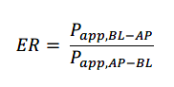  When using transfected cell lines, efflux ratios of the transfected cell line should be compared with appropriate control conditions to account for endogenous transporter activity and non-specific binding. One approach is to compare the efflux ratios from transfected cell line to the parental or empty vector-transfected cell line.  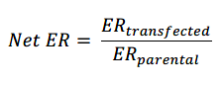  The integrity of monolayer membrane should be measured before and after experiments by examining whether transepithelial/transendothelial electrical resistance (TEER) values or permeability of paracellular markers fall within the pre-defined acceptance range.  - Uptake assays with cell-based systems:  Uptake assays can be used to evaluate whether an investigational drug is a substrate or inhibitor of solute carrier (SLC) transporters such as OCTs, OATs, OATPs and MATEs,  but can also be used to investigate efflux transporters.  When transfected cell lines are used to evaluate whether a drug is a substrate of a transporter, the drug uptake in the transfected cell line should be compared to the parental or empty vector-transfected cell line, or a comparison of the uptake with or without an inhibitor of the transporter should be performed. When assessing a drug as an inhibitor of a transporter, evaluation of the uptake of a known probe substrate using transporter-transfected cell lines alone can be sufficient. Besides transfected cell lines, human hepatocytes or hepatic cell lines in suspension or plated can be used.  The model system and experimental conditions should be validated, including culture and transport assay conditions. Transport studies should be performed under linear transport rate conditions (probe substrate concentration used is usually below its K_{m} for the transporter). Appropriate positive controls should be included in the test study to ensure the validity of the study’s results. The assays should be optimized to ensure consistent transporter function (e.g., uptake, efflux) with control experiments (e.g., positive and negative controls for substrates/inhibitors (refer to Tables 10 and 11, Section 7.4.3 for some examples), non-transfected control cells). The following conditions should be considered whenever applicable: the source of the membrane vesicles or cells, cell culture conditions (e.g., cell passage number, seeding density, monolayer age), probe substrate/inhibitor concentrations, incubation time, buffer/pH conditions, sampling interval, and methods for estimating parameters such as the IC₅₀, K_{i}, and K_{m}. In addition, adding serum or plasma proteins to the media can also affect transport activity.  Laboratory acceptance criteria for study results should be established (e.g., monolayer integrity, passive permeability, efflux or uptake of probe substrates, Km for a probe substrate, IC₅₀ for a probe inhibitor). The Km value of a probe substrate or the IC₅₀ value of a probe inhibitor should be comparable to literature-reported values.  The substrate should be readily measured with no interference from the assay matrix.  Any organic solvents should only be used at low concentrations (< 1% volume/volume and preferably < 0.5%) because some solvents can affect cell integrity or transporter function. The experiment should include a solvent (vehicle) control, and when appropriate, also a no-solvent control.  For both substrate and inhibitor studies, the sponsor should demonstrate sufficient total recovery of the drugs (e.g., 80% (55)).  7.2.2 Investigational Drug as a Transporter Substrate  The concentration range of an investigational drug should be relevant to the site of transport and should be based on the expected clinical concentration range. For transporters expressed in multiple organs (e.g., P-gp, BCRP), the sponsors should provide justification for the choice of concentrations taking into consideration the sites where the transporter is likely to play a role for drug disposition. When a range of drug concentrations is relevant, it is important to assure that low concentrations are included, as high concentrations may saturate transporters that are still active at lower drug concentrations.  If the in vitro system expresses multiple transporters (e.g., Caco-2 cells, hepatocytes), the sponsor should conduct additional experiments to confirm the findings with two or more known potent inhibitors, including the ones that are relatively specific for individual transporters.  If active transport is concluded, the passive permeability in the absence of transporters is one of the factors that could be taken into account to estimate the clinical importance of the transporter. For intestinal transporters, the role of these transporters may be limited if the permeability in the absence of transporters is high (≥ the permeability constant of the highly permeable control drug). In this case, the effect of active drug transport may be negligible as compared to the passive, concentration-gradient driven absorption of the drug. To estimate the permeability of a drug in the absence of transporters, for bi-directional assays (e.g., Caco-2 cells) the permeability constant can, for example, be determined at concentrations high enough to completely saturate the transporters (assessed as an ER ratio of 0.5 – 2). If this approach is used, it should be established that the cell monolayer is unaffected. Alternatively, the permeability of a drug can be measured in the presence of a broad inhibitor of transporters. The investigation should include a well validated, high and low permeable reference substance (for example, metoprolol and mannitol; refer to (55) for more details).  7.2.3 Investigational Drug as a Transporter Inhibitor  Normally the investigation of transporter inhibition starts with testing a high concentration of the test drug, for example, 10 × C_{max,u} for OAT1/3 and OCT2, 50 × C_{max,u} for MATEs, 10 × liver inlet C_{max,u} for OATP1B1/3, and 0.1 × the highest therapeutic dose/250 mL for orally administered P-gp or BCRP inhibitors. The drug concentration should, however, not exceed the drug’s solubility limits or cause deleterious effects (e.g., cytotoxicity) in the cells. There is at present much uncertainty regarding how to extrapolate in vitro results to in vivo when sufficiently high concentrations cannot be tested, thus the general recommendation is to test the DDI potential of these compounds in vivo, unless in vitro results are sufficiently justified.  Several factors may cause actual drug concentrations in the in vitro assays to deviate from nominal concentrations, including poor aqueous solubility, non-specific binding, and instability. Correction for binding or stability or solubility issues should be conducted when interpreting the data. Sponsors are encouraged to measure unbound drug concentrations in the medium.  If the test drug demonstrates inhibitory activity at the recommended cut-off concentration, the sponsor should test additional concentrations to estimate IC₅₀ or K_{i} values. The sponsor should evaluate at least four concentrations of the investigational drug with the probe substrate. The sponsor can then compare IC₅₀ or K_{i} values to clinical plasma or estimated intestinal concentrations of a drug to predict the potential for DDIs.  For some transporters (e.g., OATP1B1 and OATP1B3) and experimental systems, it can be relevant to determine IC50 or Ki following pre-incubation with the investigational drug, since some inhibitors demonstrated more inhibition potency after pre-incubation (56-60). This is an area of emerging information, and sponsors are encouraged to follow current literature for information on transporters of interest and relevant experimental protocols.
 | 7.3. Predictive Modeling | This section describes how modeling approaches can be used to: (1) characterize the potential for DDIs, (2) indicate whether a dedicated clinical DDI study should be conducted, and (3) support clinical recommendations in the absence of a clinical DDI study. The modeling approaches discussed are static mechanistic models and dynamic mechanistic models (also known as PBPK models).  Various mathematical and mechanistic modeling approaches can help translate in vitro observations into predictions of potential clinical DDIs. In some cases, findings from in vitro and early clinical studies, in conjunction with model-based predictions, can be used to determine whether initial or additional clinical investigations of a drug’s DDI potential as a victim or perpetrator of CYP enzyme- or transporter-mediated interaction should be conducted.  Section 3 of this guideline describes the evaluation of in vitro metabolism and transporter studies to determine whether further evaluation of a drug as a victim or perpetrator of CYP enzyme- or transporter-mediated interactions should be conducted. If those assessments indicate further evaluations should be conducted, they may be conducted using mechanistic static models or PBPK models (if adequate data are available, as described below) or by conducting a clinical DDI study. For each drug development program, multiple approaches for assessing DDI risk may be feasible.  Depending on the results of the mechanistic static or PBPK modeling, follow-up clinical DDI studies could be needed.  The use of appropriate in vitro experimental conditions is critical to any model used for a quantitative prediction.  7.3.1 Using Mechanistic Static Models for DDI Predictions  A mechanistic static model incorporates detailed drug disposition and drug interaction mechanisms for both interacting and substrate drugs (61, 62). The model includes the effect of reversible and time dependent enzyme inhibition, as well as enzyme induction. Thus, the model can estimate the effect of several interaction processes. The overall effect of the perpetrator drug on the substrate drug is represented as AUCR (ratio of the AUC of the substrate drug in the presence and absence of the perpetrator drug) and is given by the equation below.  7.3.1.1. Evaluation of an Investigational Drug as a DDI Perpetrator  For a drug that is both an inhibitor and an inducer of an enzyme, in addition to the combination of inhibition and induction, a drug’s inhibition potential alone (A and B only, assuming C is equal to 1 in the equation below), and induction potential alone (C only, assuming A and B are equal to 1 in the equation below) should be conducted. Concurrent prediction can lead to a false negative prediction if the inhibition potential is over-predicted, thus masking the induction effect (63). If the induction potential is over-predicted, it will mask the inhibition effect.  7.3.1.2. Evaluation of Investigational Drug as a Victim of CYP-Mediated DDIs  In principle, mechanistic static models can be used to predict DDI effects with a less potent perpetrators after the model has been confirmed with index perpetrators.  7.3.1.3. Evaluation of The Potential for Transporter-Mediated DDIs  Although there are fewer examples, with adequate data about transporters involved and the fraction of drug transported at various tissues (ft), the mechanistic static models as noted below and in Table 3 can be used to evaluate transporter-mediated DDIs (64-68). The potential applications and considerations listed for PBPK modeling (refer Section 7.3.2.2) are also relevant for mechanistic static modeling.  Equation to calculate AUCR of the substrate drugs (AUC plus investigational drug/AUC minus investigational drug)  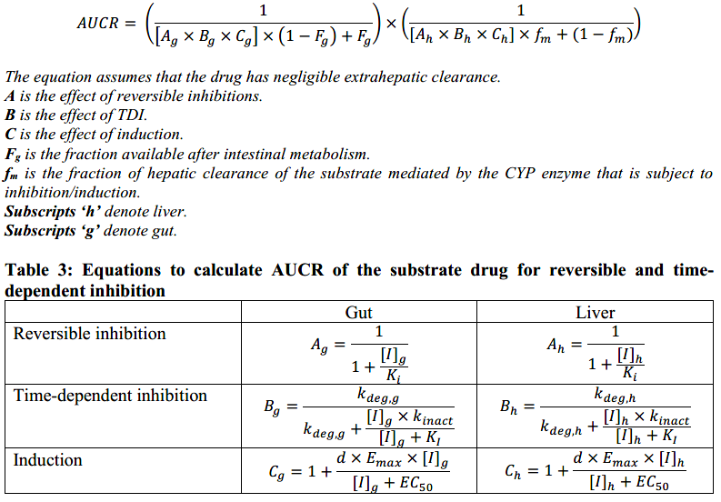  Each value can be estimated with the following equations:  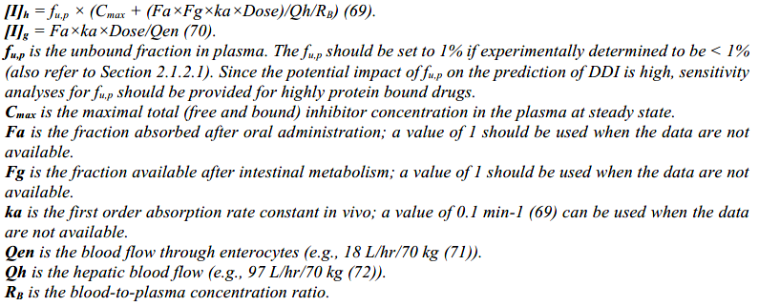  Reports of modeling exercises and results should provide support for input parameters based on data and/or scientific literature.  If the model estimates AUCR between 0.80 to 1.25, the risk of a clinically relevant interaction is low, and additional evaluations of the drug as a perpetrator for the studied enzyme are not needed. If AUCR is outside 0.80 to 1.25, further evaluation should be conducted to quantify the effect. Alternatively, sponsors should provide sufficient justification(s) if no further assessments are planned.  Mechanistic static models are currently used to determine whether the potential for a DDI can be ruled out. This use, along with the current equations used for drug concentrations in the gut and liver (above), can be overly conservative and thus result in false positive results. There are ongoing efforts to determine the most relevant drug concentrations in gut and liver (6, 62). The results of these efforts could lead to the use of mechanistic static models to provide quantitative estimates of interactions due to CYPs and/or transporters. If additional research supports the use of the models in a more quantitative manner, reports of results should include justifications for both system- and drug-dependent parameters and sensitivity analyses when relevant.  7.3.2 Using PBPK Models to Predict Enzyme or Transporter-Based DDIs  PBPK models can assist in the evaluation of the DDI potential of an investigational drug and/or a metabolite as a victim or perpetrator of enzyme or transporter-mediated interactions. Compared with a mechanistic static model, since a PBPK model considers changes in concentration over time, information regarding time-dependent interactions can be obtained in more detail. When PBPK modeling is used to support drug development and regulatory decisions, it is important to justify any model assumptions, the physiological and biochemical plausibility of the model, variability, and uncertainty measures. PBPK analysis reports should include a description of the context of use for the model, model structure and development plan, the sources and justifications for both system- and drug-dependent parameters, and an adequate sensitivity analysis plan. When using predefined models (structural and error) from commercially available software, the software version and any deviations from predefined models should be described (73). In some scenarios, simulation data from a robust PBPK model can be used to conclude the DDI potential of an investigational drug instead of a dedicated clinical DDI study.  In general, broad recommendations for PBPK model verification, validation and the reporting of the results are beyond the scope of this guideline (refer to (74-78) for guidance on these topics). Instead, this guideline describes the utility of PBPK modeling for the evaluation of DDIs, with the understanding that models should be demonstrated as fit-for-purpose. Specific best practice considerations for use of PBPK modeling for the evaluation of DDIs are also described below.  7.3.2.1 Potential Applications of PBPK to the Evaluation of CYP-Mediated DDIs  Related to evaluation of CYP-mediated DDIs, PBPK models can help select key DDI studies for a development program and support the study design for clinical DDI studies. They can also be used to explain PK observations, such as observed PK differences that are due to genetic polymorphism.  When evaluating a drug as a potential victim of CYP-mediated DDIs, PBPK models can be used to predict DDI effects with a less potent perpetrator after the model has been confirmed with index perpetrators. They can also predict clinically relevant DDI scenarios, such as the effect following multiple dose administration of the substrate drug if only single dose administration is evaluated in a clinical DDI study.  When evaluating a drug as a potential perpetrator of CYP-mediated DDIs, PBPK models can be used to support the lack of clinical DDI potential and to predict DDI effects under different dosing regimens after the model has been confirmed with an index substrate.  7.3.2.1.1 Modeling Considerations - PBPK for Evaluation of CYP Interactions for Drugs as  Substrates  Sponsors should consider the following when using PBPK modeling to predict the DDI potential of the investigational drug (including clinically relevant metabolite(s)) as a CYP enzyme substrate:  - The base PBPK model of the investigational drug should describe the available clinical PK data using different dosing regimens (e.g., a dose proportionality study, repeated dosing) and dosing routes (e.g., intravenous or oral).  - The major metabolic and other elimination pathways should be quantitatively assigned in the investigational drug’s model according to available in vitro and clinical data.  - The uncertainty of the PBPK model parameters should be assessed using sensitivity analysis. For example, since the potential impact of fu,p on the prediction of DDI is high, sensitivity analyses for fu,p is expected for highly protein bound drugs.  - The index perpetrator models should describe the available clinical PK data using different dosing regimens (e.g., a dose proportionality study) and, as appropriate, different dosing routes (e.g., intravenous or oral).  - The acceptability of index perpetrator models should be independently confirmed with regard to their modulating effect on the PK of sensitive enzyme substrates in humans.  - If complex metabolic and transport mechanisms are expected, the substrate and perpetrator models should include the relevant disposition and interaction mechanisms and should be deemed fit-for-purpose.  7.3.2.1.2 Modeling Considerations - PBPK for Evaluation of CYP Interactions for Drugs as  Perpetrators  Sponsors should consider the following when using PBPK modeling to predict the drug interaction potential of an investigational drug (including clinically relevant metabolite(s)) as a CYP enzyme perpetrator:  - The base PBPK model of the investigational perpetrator (and its metabolites, when relevant) should describe the available clinical PK data using different dosing regimens (e.g., a dose proportionality study, repeated dosing) and, as appropriate, dosing routes (e.g., intravenous or oral).  - The DDI parameters should be assigned in the perpetrator’s model according to available in vitro and clinical data such as clinical DDI study(ies).  - For perpetrators that exhibit both inhibition and induction, the inhibition and induction mechanisms should be separately considered, in addition to the combination of inhibition and induction, to ensure a conservative prediction of in vivo enzyme inhibition or induction. In most cases, the clinically relevant effect of interest is the combined effect.  - The index substrate models should describe the available clinical PK data using different dosing regimens (e.g., a dose proportionality study) and as appropriate, different dosing routes (e.g., intravenous or oral).  - Sensitive index substrate models should be independently confirmed with regard to the effect of a strong index perpetrator-mediated altered enzyme activity on its PK in humans.  - The simulation should include the highest clinical dose and shortest dosing interval of the investigational perpetrator. The PK and modulating effect of the highest dose should be confirmed before use in the simulation.  - Sensitivity analyses should be conducted for parameters exhibiting high levels of uncertainty.  7.3.2.2 Potential Applications of PBPK to the Evaluation of Transporter-Mediated DDIs  Related to evaluation of transporter-mediated DDIs, PBPK models can be used to support the initial study design for clinical DDI studies when a DDI liability is identified.  When evaluating a drug as a potential victim of transporter-mediated DDIs, PBPK models can be used to explain PK observations, such as PK differences that are due to genetic polymorphism (e.g., OATP1B1). PBPK models can also be used to explore involvement of specific transporters in a drug’s ADME.  When evaluating a drug as a potential inhibitor of transporter-mediated DDIs, PBPK models can support negative DDI prediction when the drug is an in vitro inhibitor for a basolateral uptake transporter. They can also be used to evaluate the effect of an investigational drug on the PK of a transporter substrate with a well characterized pathway.  7.3.2.2.1 Modeling Considerations - Drug as a Transporter Substrate  In general, quantitatively confirming the model regarding the involvement of the specific transporter in the relevant organ(s) is challenging. Comprehensive model exploration and/or clinical studies should be conducted for quantitative model confirmation.  7.3.2.2.2 Modeling Considerations - Drug as a Transporter Inhibitor  In general, when using PBPK models to evaluate a drug as a transporter inhibitor, the substrate model should be confirmed for the relevant transporter(s). Further, the analysis report should include a sensitivity analysis for the inhibition constant.
 | 7.4. List of Drugs that can be used in In Vitro Studies | 7.4.1 CYP Enzymes  7.4.1.1 CYP Enzyme Substrates for In Vitro Studies  Probe substrates are used to measure perpetrator properties of a drug candidate on individual CYP enzymes (see Table 4 for examples of substrates). The substrates should be selective, or the formation of a specific metabolite is selective for a CYP enzyme. Concentration of the substrate should be at or below its Km for the reaction.  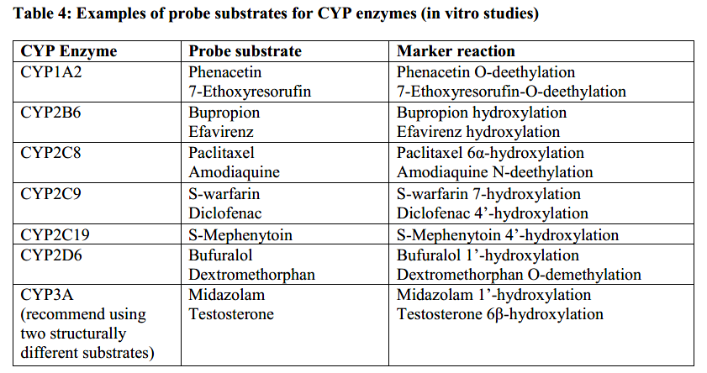  7.4.1.2 CYP Enzymes Perpetrators for In Vitro Studies  The enzyme inhibitors and inducers are used to phenotype individual CYP enzymes involved in the drug candidate metabolism in vitro. In general, the inhibitors/inducers should be selective at the concentration used. The following tables are provided to help sponsors design in vitro studies and to evaluate the interaction potential (Tables 5-7). These tables are not exhaustive, and sponsors can use other inhibitors/inducers with appropriate justification.  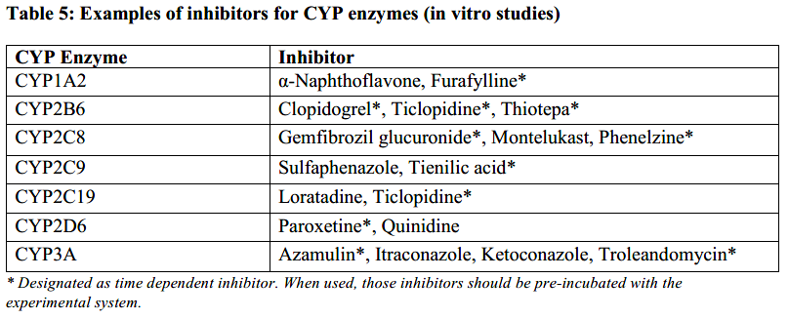  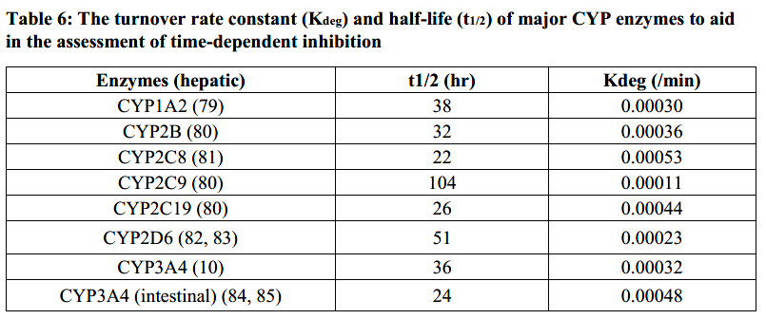  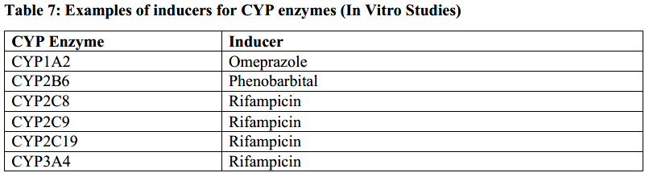  7.4.2 UGTs  7.4.2.1 UGT Substrates for In Vitro Studies  The list provided in Table 8 is not exhaustive, and sponsors can use other substrates with appropriate justification.  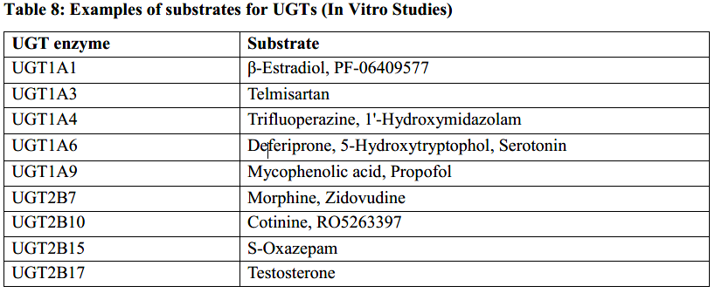  7.4.2.2 UGT Inhibitors for In Vitro Studies  There is a lack of relatively selective inhibitors for UGT1A3, UGT1A6, UGT2B7, and UGT2B15. In the absence of selective inhibitors, a combination of methods including use of recombinant UGT isoform, HLM expressing polymorphic variants of UGT isoform (where appropriate), the relative activity factor (RAF) or relative expression factor (REF) approach, and activity correlation approach can be employed. Comparative studies with multiple inhibitors can also help assess the involvement of a particular isoform. When using individual recombinant enzyme preparations, the difference in the amount and enzyme activity of UGTs between the recombinant enzyme systems and the human liver should be considered.  The list provided in Table 9 is not exhaustive, and sponsors can use other inhibitors with appropriate justification.  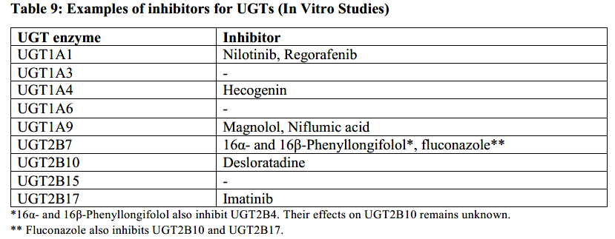  7.4.3 Transporters  Some substrates are not specific for an individual transporter. When an experimental system expressing multiple transporters is used, a more specific substrate is preferred. The following tables provide examples of transporter substrate and inhibitors for in vitro studies (Tables 10 and 11).  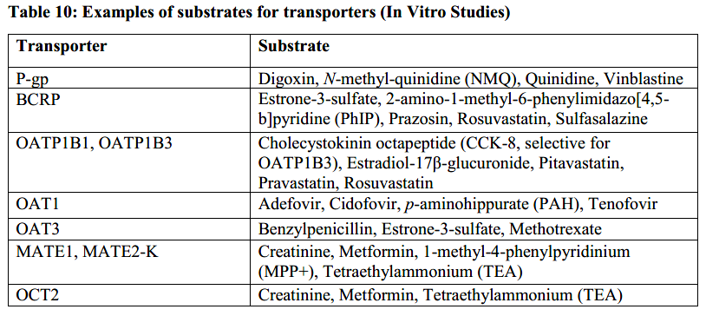  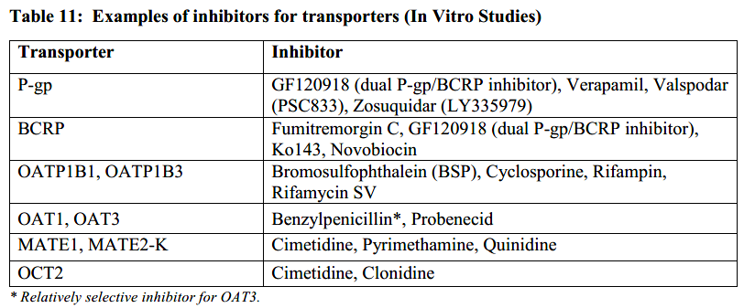
 | 7.5 List of Drugs that can be used in Clinical Studies | 7.5.1 CYPs Enzymes  7.5.1.1 CYP Enzyme Substrates for Clinical Studies  Ideally, drugs selections should be based on sensitivity, specificity, safety profiles, and reported clinical DDI studies with inhibitors, as well as an absence of studies that indicate the drug does not meet the criteria.  - Index substrates predictably exhibit exposure increase due to inhibition of a given metabolic pathway and results are available from prospective clinical DDI studies. These drugs can be safely administered with potential inhibitors, sometimes with a dose reduction.  - Sensitive index substrates are index drugs that demonstrate an increase in AUC of ≥5-fold with strong index inhibitors of a given metabolic pathway in clinical DDI studies.  - Moderately sensitive substrates are drug that demonstrate an increase in AUC of ≥2- to <5-fold with strong index inhibitors of a given metabolic pathway in clinical DDI studies.  Sponsors are encouraged to consider the unique characteristics of each drug when designing DDI studies. For example, a drug could be a substrate for multiple CYPs or a CYP plus a transporter. In such a case, the selection of an index drug for a study should take into consideration the knowledge about the potential perpetrator (enzymes and/or transporters which it could inhibit).  The drugs listed in Table 12 below have been identified as appropriate index substrates for clinical DDI studies. Other drugs can be proposed, considering the criteria above.  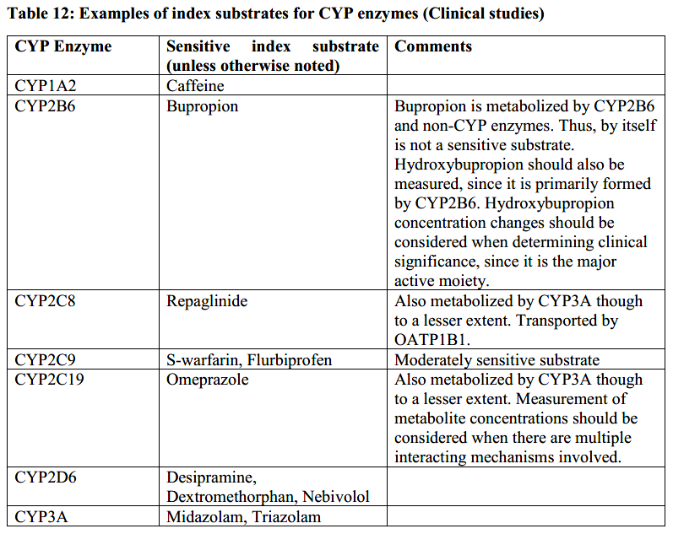  7.5.1.2 CYP Enzyme Inhibitors for Clinical Studies  Index inhibitors predictably inhibit metabolism via a given pathway, and results are available from prospective clinical DDI studies. Strong and moderate inhibitors are drugs that increase the AUC of sensitive index substrates of a given metabolic pathway ≥5-fold and ≥2- to <5-fold, respectively.  Ideally, index inhibitors should be selected based on potency and selectivity of inhibition, safety profiles, availability of reported clinical DDI studies with different in vivo substrates, as well as an absence of studies that indicate the drug does not meet the criteria.  Sponsors are encouraged to consider the unique characteristics of each drug when designing DDI studies. For example, a drug could inhibit multiple CYPs or a CYP plus a transporter. Sponsors should select an index inhibitor for a study based on knowledge about the potential CYPs and transporters involved with the substrate’s disposition.  The drugs listed in Table 13 below have been identified as appropriate index inhibitors for clinical DDI studies. Other drugs can be proposed, considering the criteria described above.  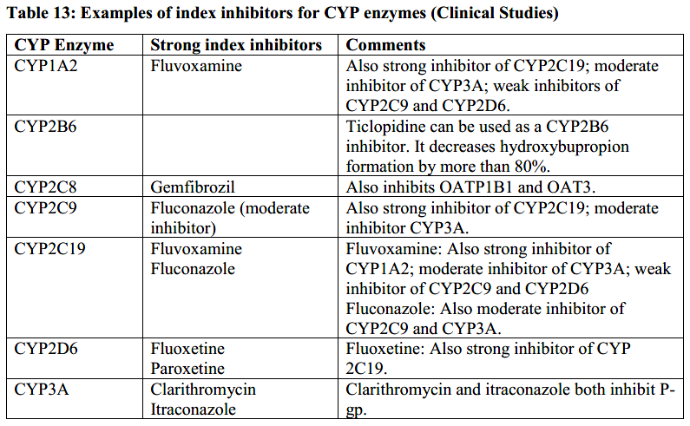  7.5.1.3 CYP Enzyme Inducers for Clinical Studies  Inducers in Table 14 below were selected based on potency of induction, safety profiles, and availability of clinical DDI studies with different clinical substrates. Due to the mechanisms of induction, inducers usually regulate the expression of multiple enzymes and transporters.  Strong and moderate inducers decrease the AUC of sensitive index substrates of a given metabolic pathway by ≥80% and ≥50% to <80%, respectively.  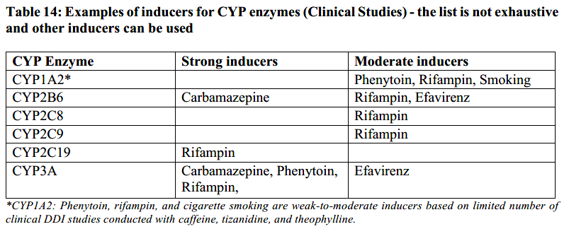  7.5.2 UGTs  UGT substrates and perpetrators that are useful for clinical DDI studies are listed below (Tables 15-17). These lists are not exhaustive, other substrates/perpetrators can be used with appropriate justifications.  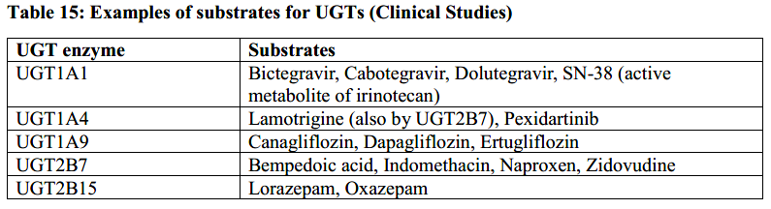  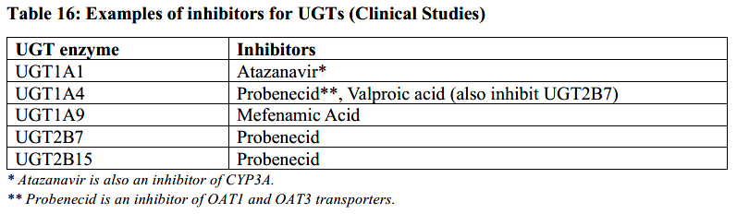  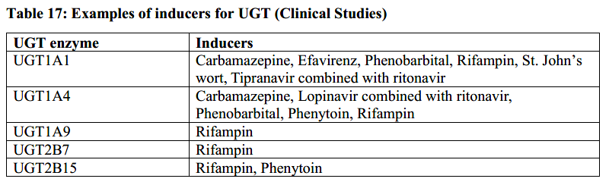  7.5.3 Transporters  7.5.3.1 Transporter Substrates for Clinical Studies  Transporter substrates that are useful for clinical DDI studies are listed in Table 18 below. Many of them are substrates of multiple transporters and/or enzymes. Thus, the extrapolation of results from these studies to other drugs can be challenging and as indicated earlier (refer to main text), index substrates are not available for transporters. Interpretation of the study results should take into consideration the knowledge of the transporter inhibition properties for the investigational drug as well as its effect on metabolic enzymes. It is most useful to select a transporter substrate that is likely to be administered in the intended patient population for the investigational drug.  The listed substrates exhibit markedly altered PK profiles following co-administration of known inhibitors of the transporter, meeting the criteria below. In addition, they are generally safe for use in clinical DDI studies.  Criteria  The criteria below were used to select recommended transporter substrates for use in DDI studies to characterize a drug’s transporter inhibition properties. Results from studies conducted with clinically relevant doses were used for selection of drugs. When possible, drugs most relevant for global drug development programs were selected.  - P-gp: (1) AUC fold-increase ≥2 with itraconazole, quinidine, or verapamil co-administration, (2) in vitro transport by P-gp expression systems, and (3) not extensively metabolized in vivo.  - BCRP: (1) AUC fold-increase ≥2 with pharmacogenetic alteration of ABCG2 (421C>A) and (2) in vitro transport by BCRP expression systems.  - OATP1B1/OATP1B3: (1) AUC fold-increase ≥2 with rifampin (single dose) or cyclosporine co-administration, or pharmacogenetic alteration of SLCO1B1 (521T>C) and (2) in vitro transport by OATP1B1 or OATP1B3 expression systems.  - OAT1/OAT3: (1) AUC fold-increase ≥2 with probenecid co-administration, (2) fraction excreted into urine as an unchanged drug ≥0.5, and (3) in vitro transport by OAT1 and/or OAT3 expression systems.  - OCT2/MATEs: (1) AUC fold-increase ≥2 with dolutegravir or pyrimethamine; (2) fraction excreted into urine as an unchanged drug ≥0.5, and (3) in vitro transport by OCT2 and/or MATEs expression system.  Note: The list is not exhaustive and sponsors can use substrates that are not listed in the table if the drug’s transport properties are well understood and similar to the criteria above.  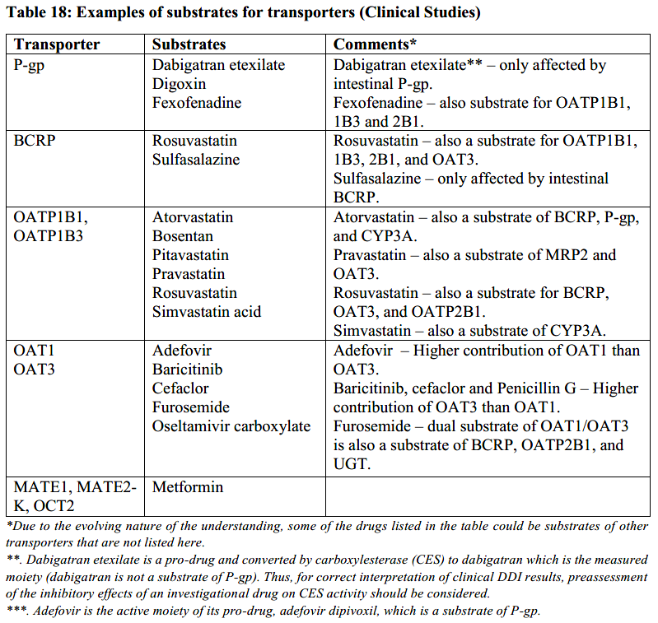  7.5.3.2. Transporter Inhibitors for Clinical Studies  Transporter inhibitors that are useful for clinical DDI studies are listed in Table 19 below. Many of them not only inhibit the specified transporters but also inhibit some other transporters and/or CYP enzymes. Thus, extrapolation of results from these studies to other drugs can be challenging as indicated earlier (refer to main text), index inhibitors are not available for transporters.  Interpretation of the study results should take into consideration the knowledge of transport and metabolic/elimination pathways for the investigational drug. It is most useful to select a transporter inhibitor that is likely to be administered in the intended patient population for the investigational drug.  The listed inhibitors lead to markedly altered PK profiles of known substrates of the transporter following co-administration, meeting the criteria below. In addition, they are generally safe for use in clinical DDI studies.  Criteria  The criteria below were used to select recommended transporter inhibitors for use in DDI studies to characterize a drug’s properties as a transporter substrate. Results from studies conducted with clinically relevant doses were used for selection of drugs. When possible, drugs most relevant for global drug development programs were selected.  - P-gp: (1) AUC fold-increase of digoxin, dabigatran, or fexofenadine ≥2 with co-administration and (2) in vitro inhibitor.  - BCRP: (1) AUC fold-increase of rosuvastatin ≥2 or close to 2-fold with co-administration and (2) in vitro inhibitor.  - OATP1B1/OATP1B3: (1) AUC fold-increase ≥2 for at least one of the clinical substrates with co-administration and (2) in vitro inhibitor.  - OAT1/OAT3: (1) AUC fold-increase ≥2 for at least one of clinical the substrates with co-administration and (2) in vitro inhibitor.  - OCT2/MATE: (1) AUC fold-increase of metformin ≥ 2 with co-administration and (2) in vitro inhibitor.  Note: The list is not exhaustive and sponsors can use inhibitors that are not listed in the table if the drug’s transporter inhibition properties are well understood and similar to the criteria above.  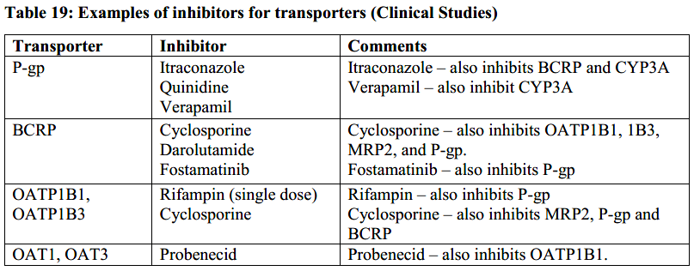  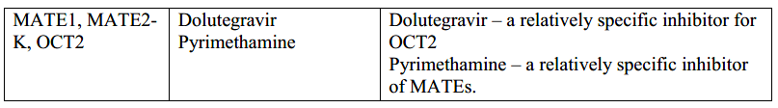
8. REFERENCES |  | 